Exploring Azure

Contents

Explore Relational Data in Azure 3

Explore non-relational data in Azure 5

Provision an Azure Storage account 5

Explore blob storage 5

Explore Azure Data Lake Storage Gen2 8

Explore Azure Files 9

Explore Azure Tables 10

Create a Cosmos DB account 11

Create a sample database 11

View and create items 12

Query the database 13

Explore data analytics in Azure 14

Create a workspace 14

Create a Lakehouse 14

Ingest data 15

Query data in a Lakehouse 16

Visualize data in a Lakehouse 17

Explore real-time analytics in Microsoft Fabric 19

Create a workspace 19

Create a KQL database 19

Create an eventstream 20

Query real-time data in a KQL database 22

Explore fundamentals of data visualization with Power BI 23

Import Data 23

Explore a data model 23

Create a report 26

## Explore Relational Data in Azure

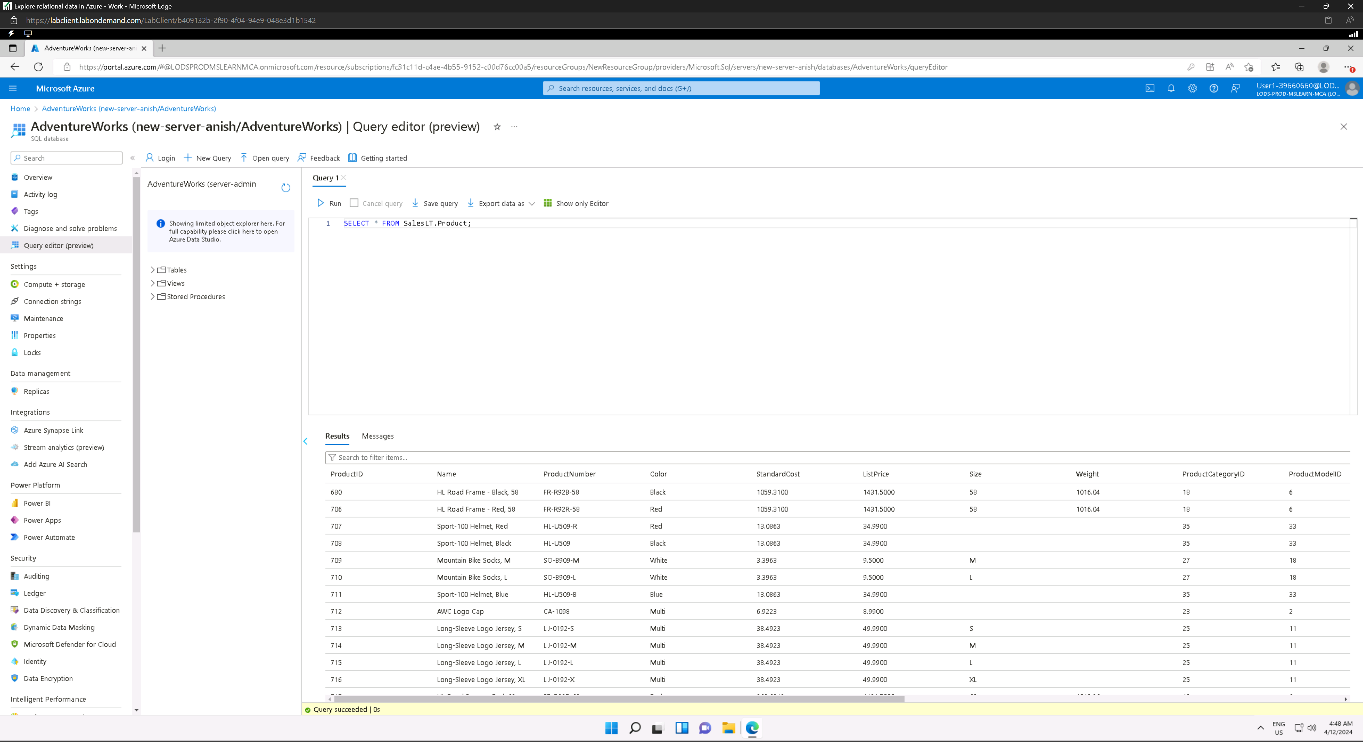

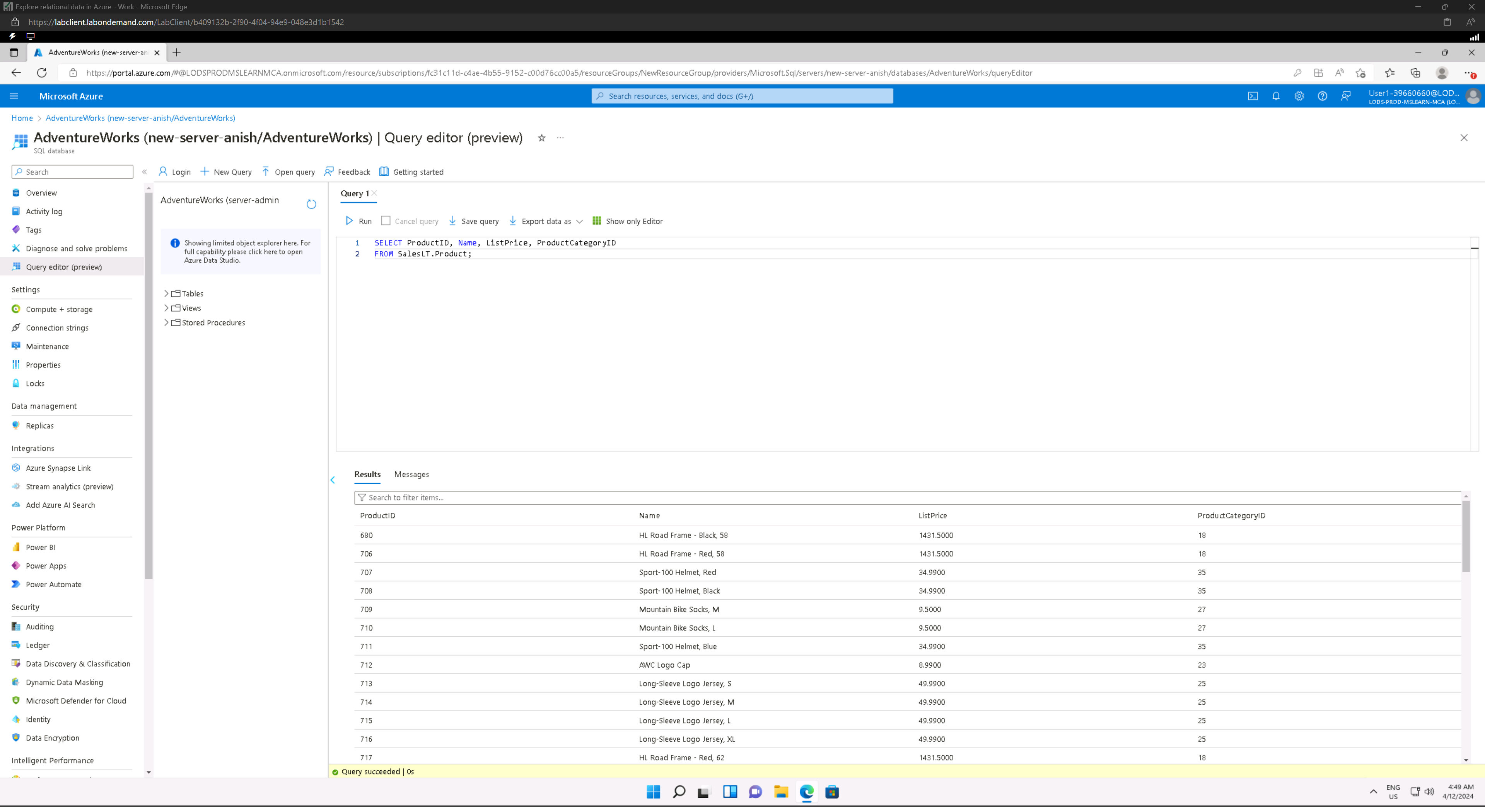

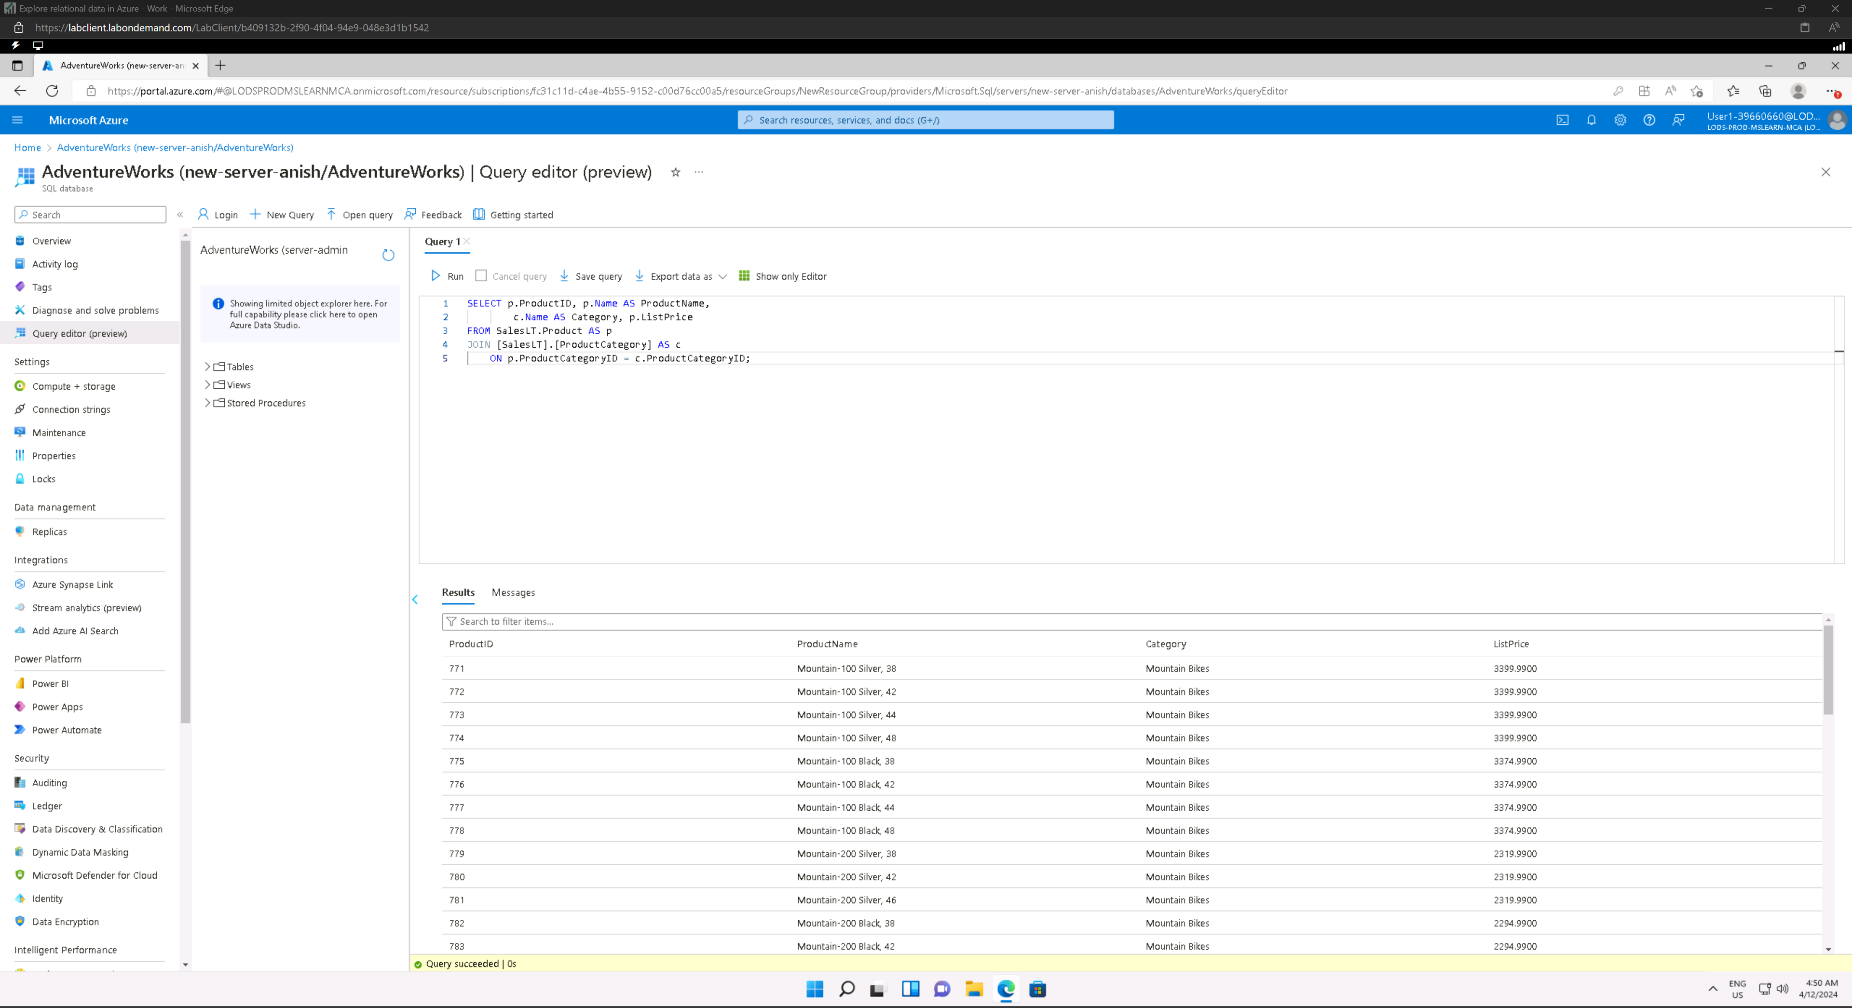

## Explore non-relational data in Azure

### Provision an Azure Storage account

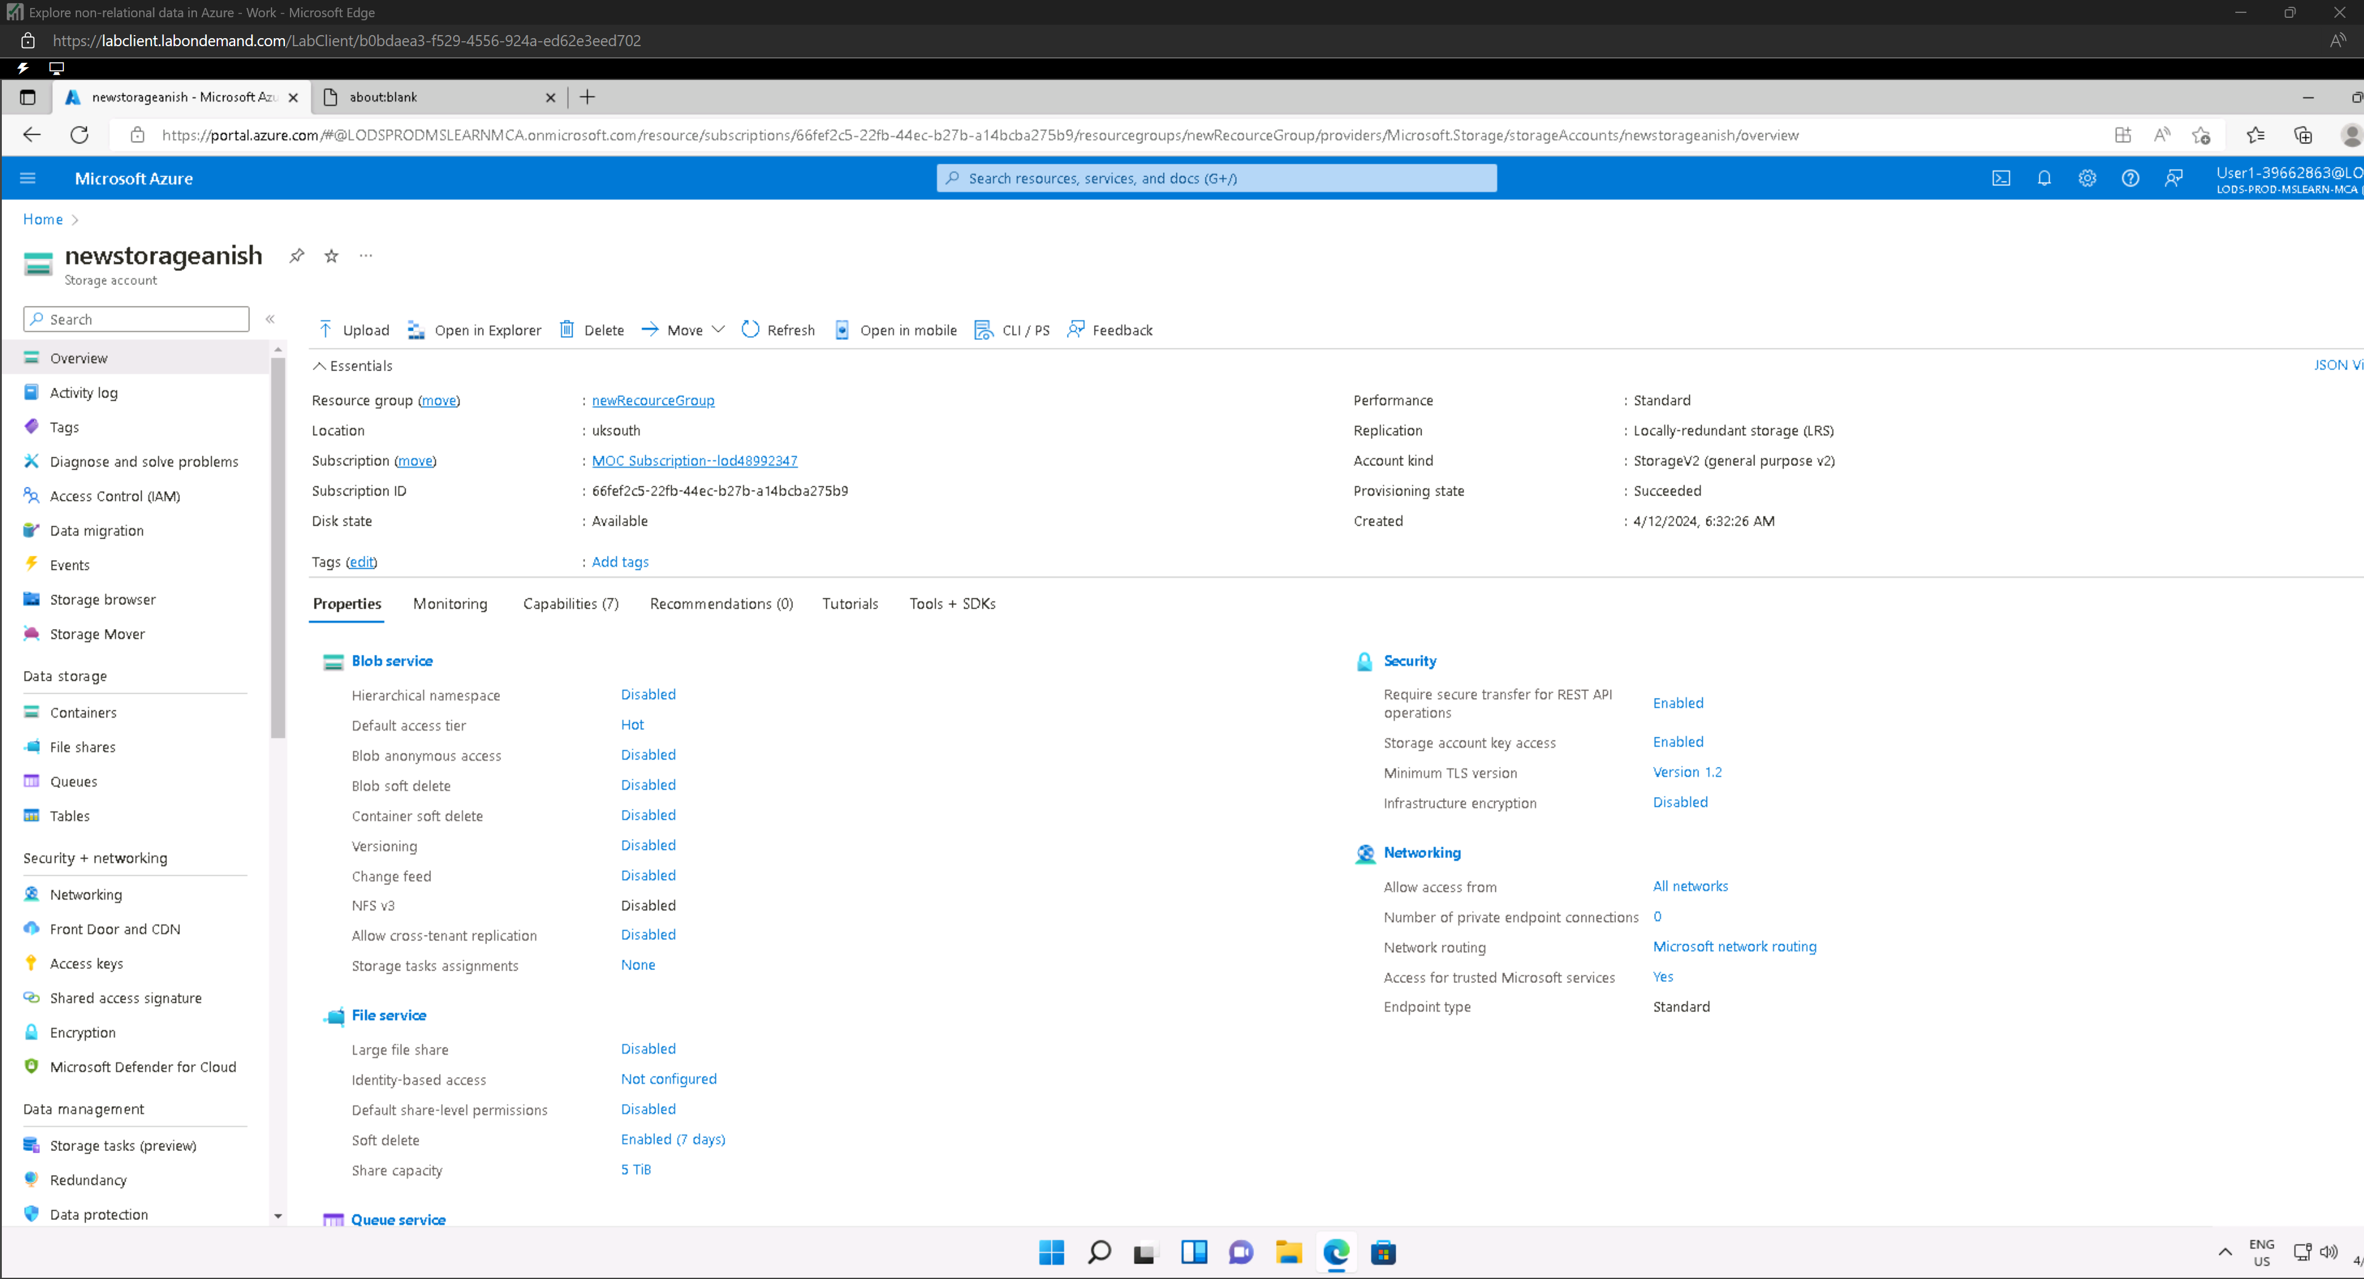

### Explore blob storage

#### Creating container

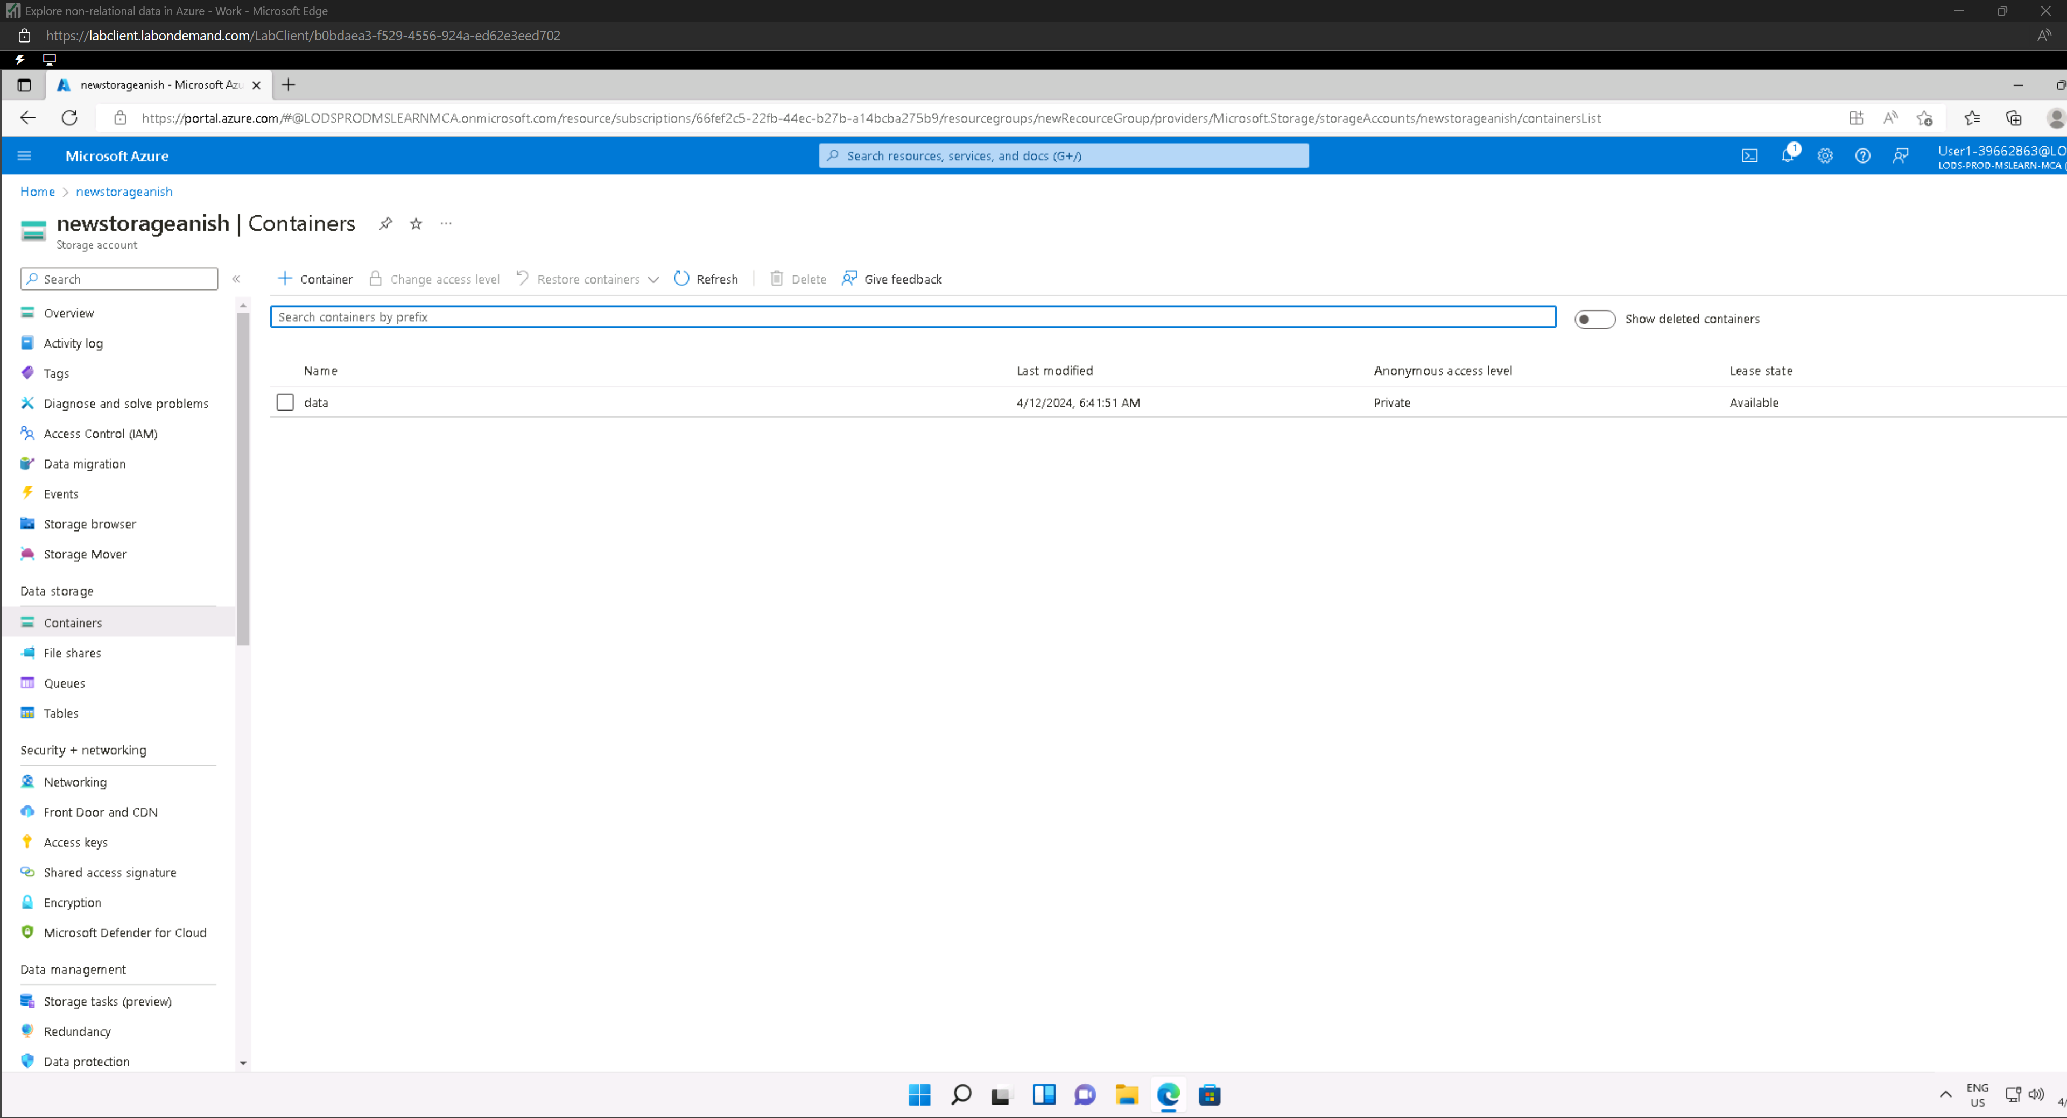

#### Storage Browser

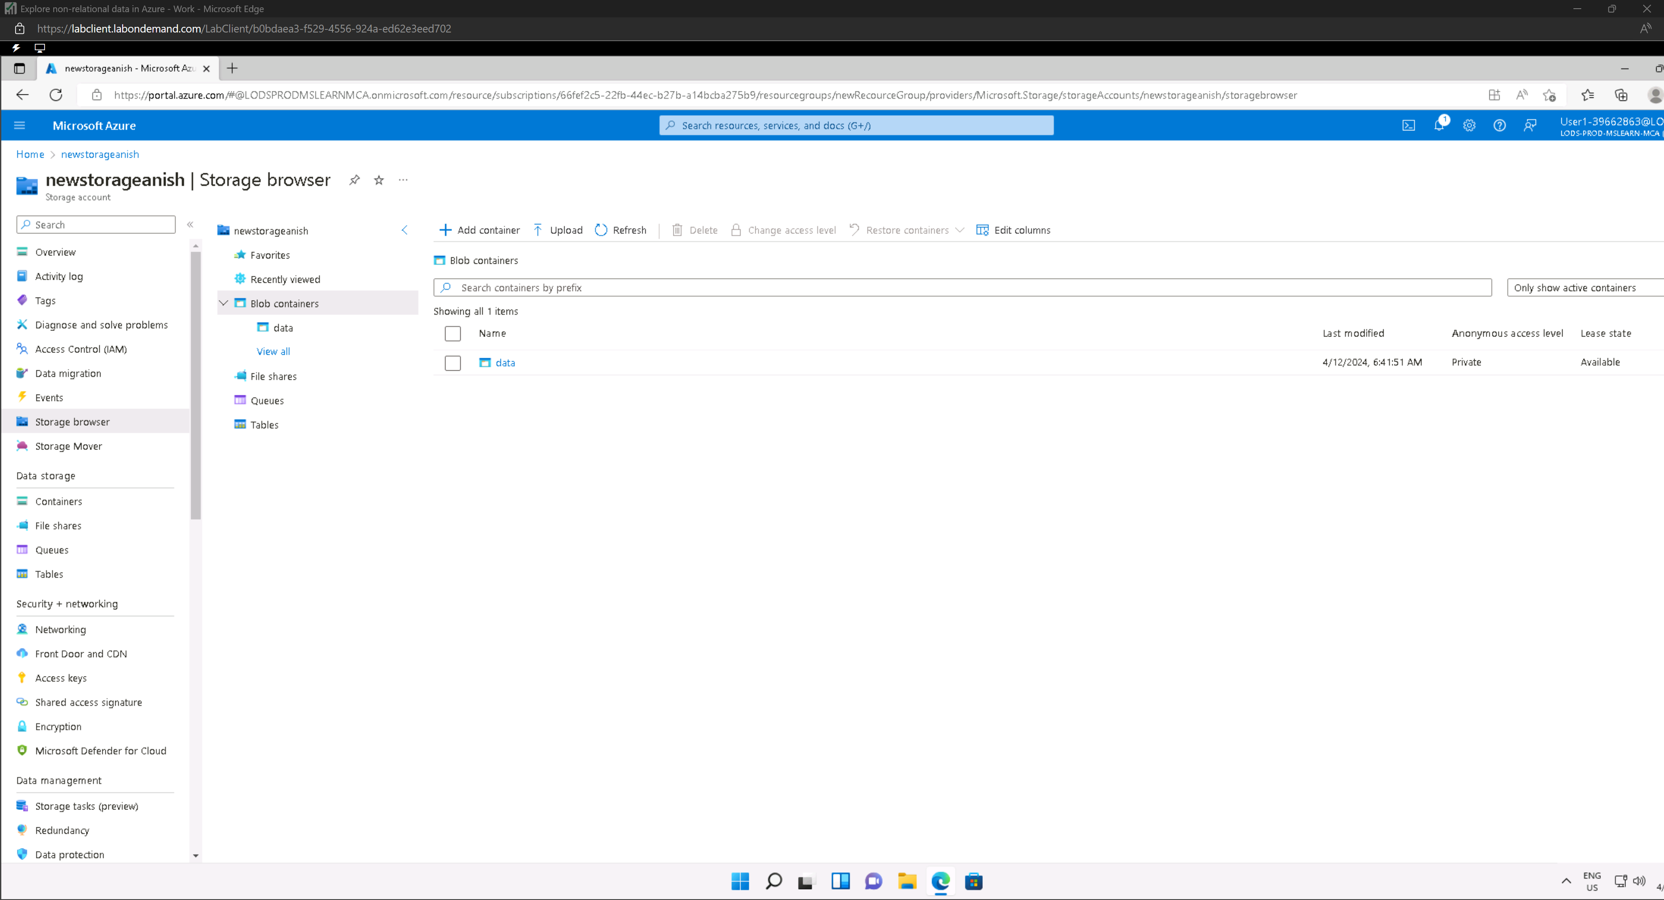

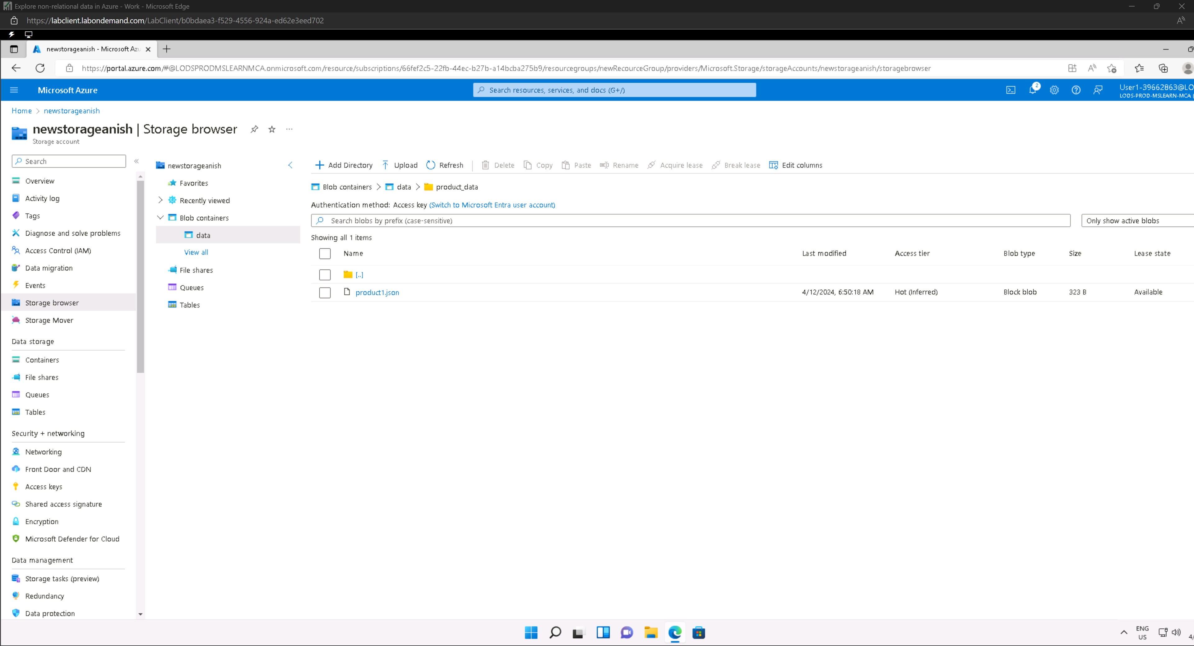

Container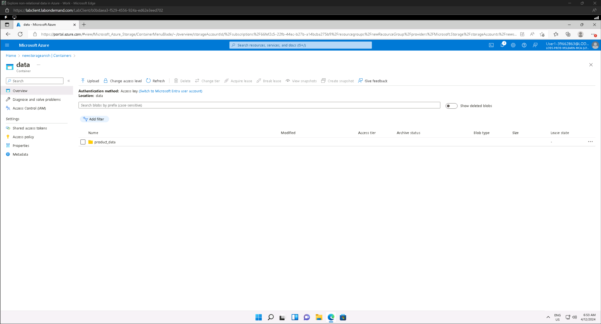

### Explore Azure Data Lake Storage Gen2

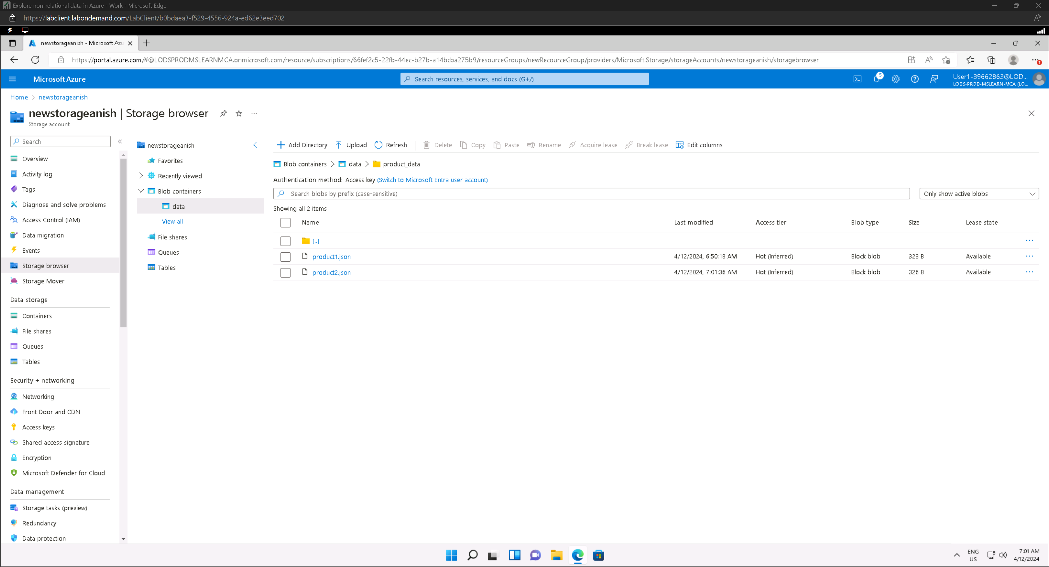

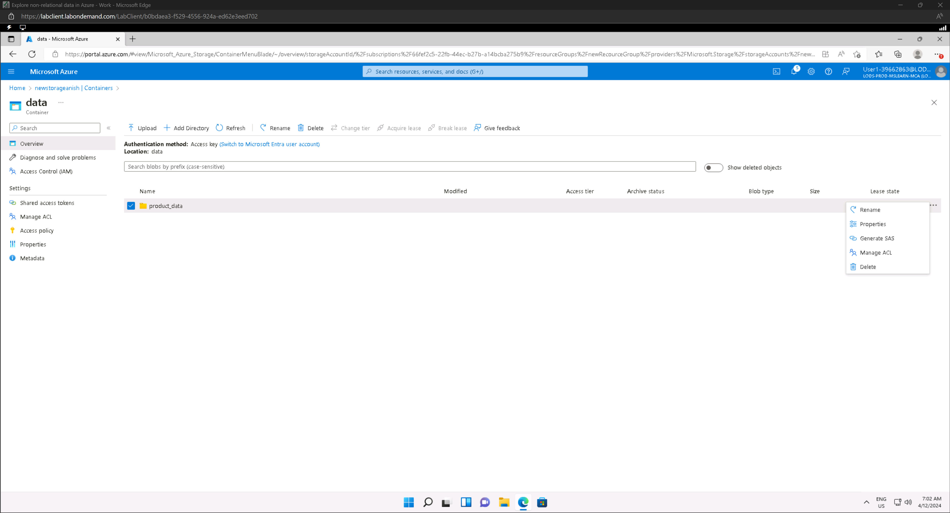

### Explore Azure Files

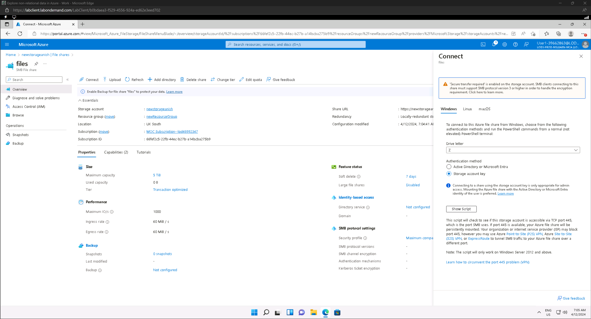

### Explore Azure Tables

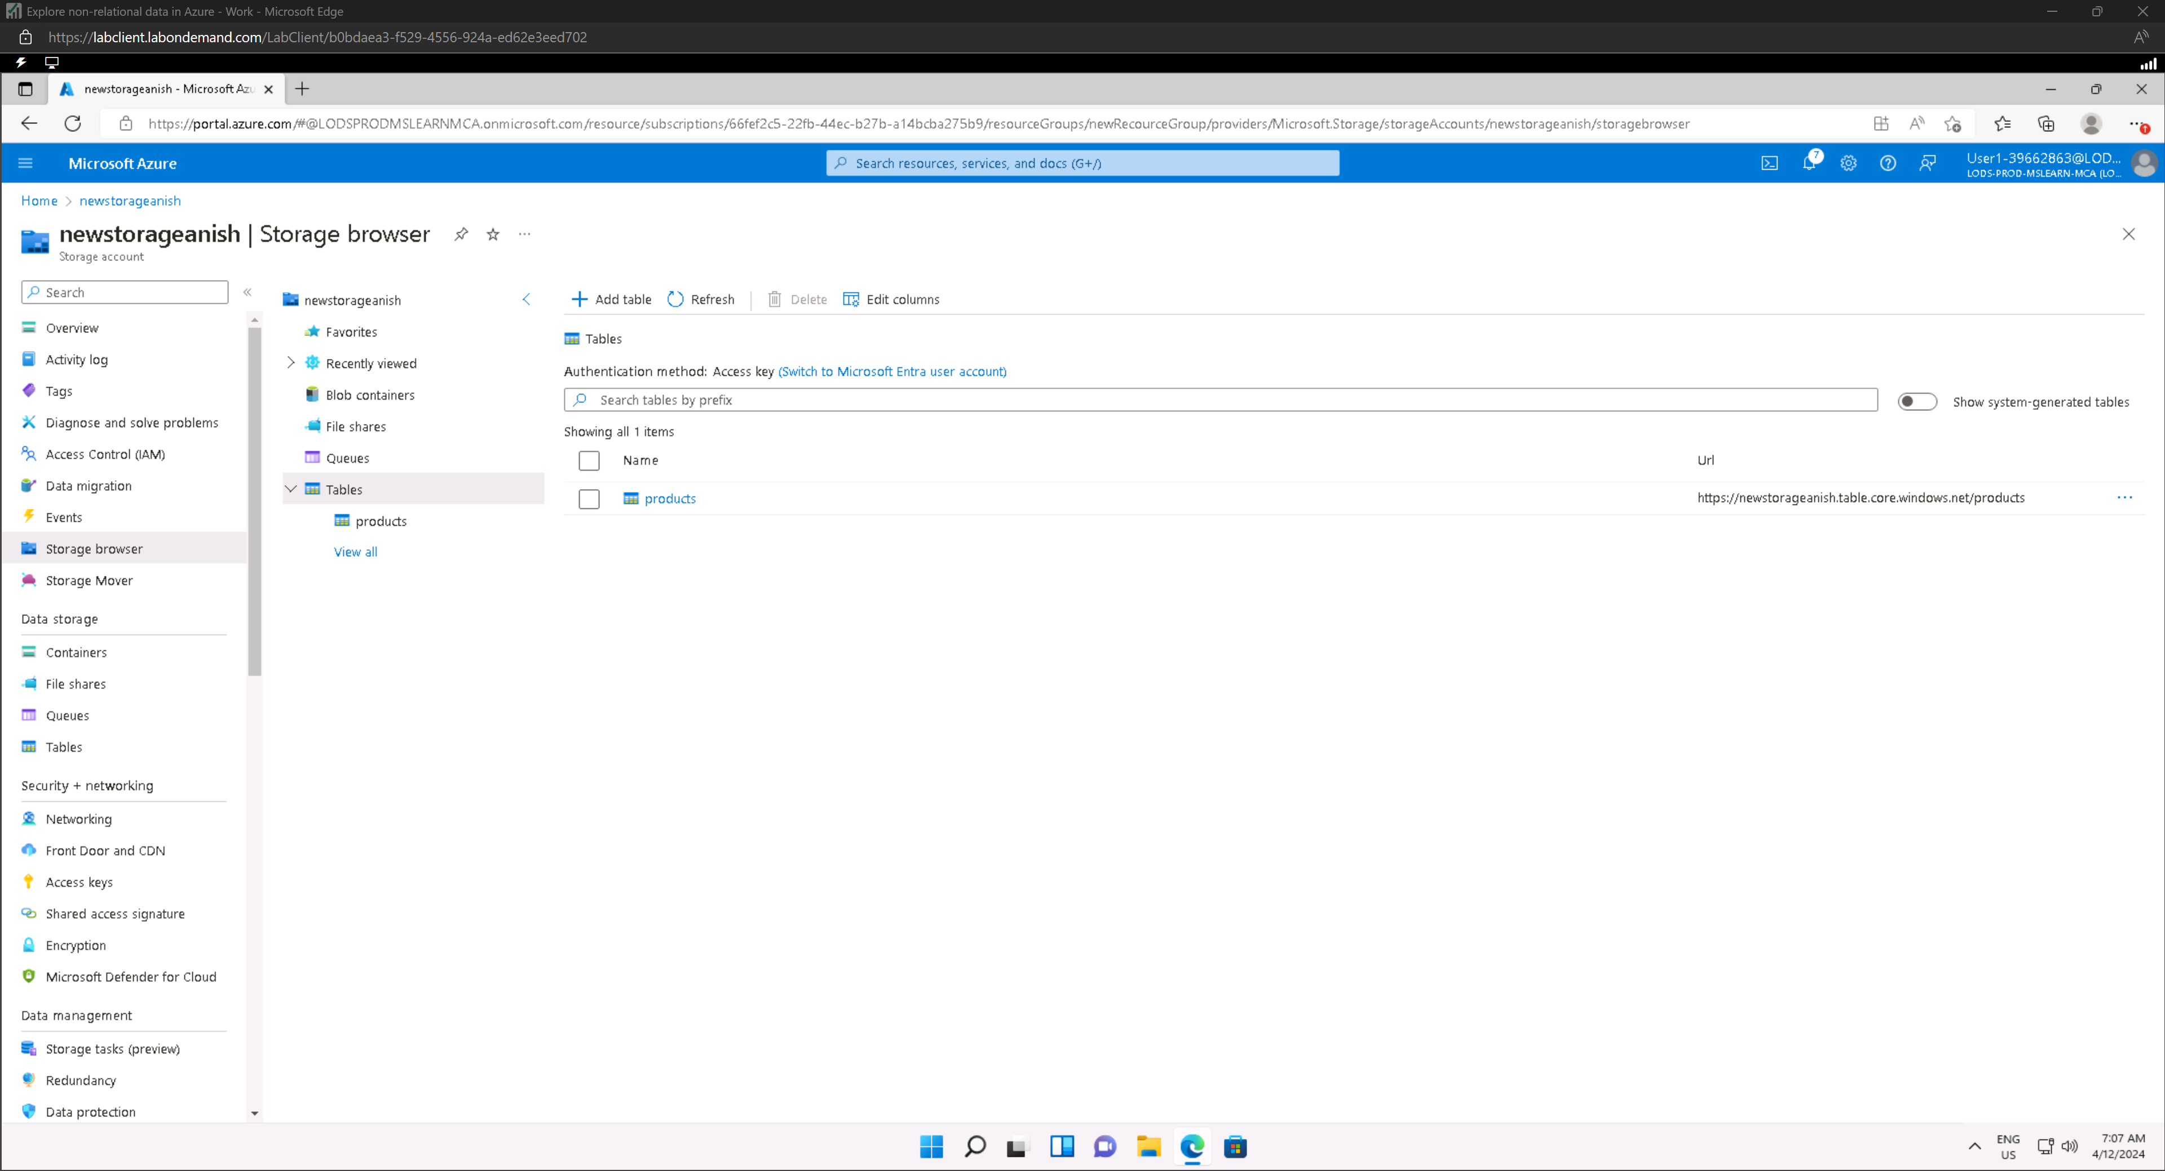

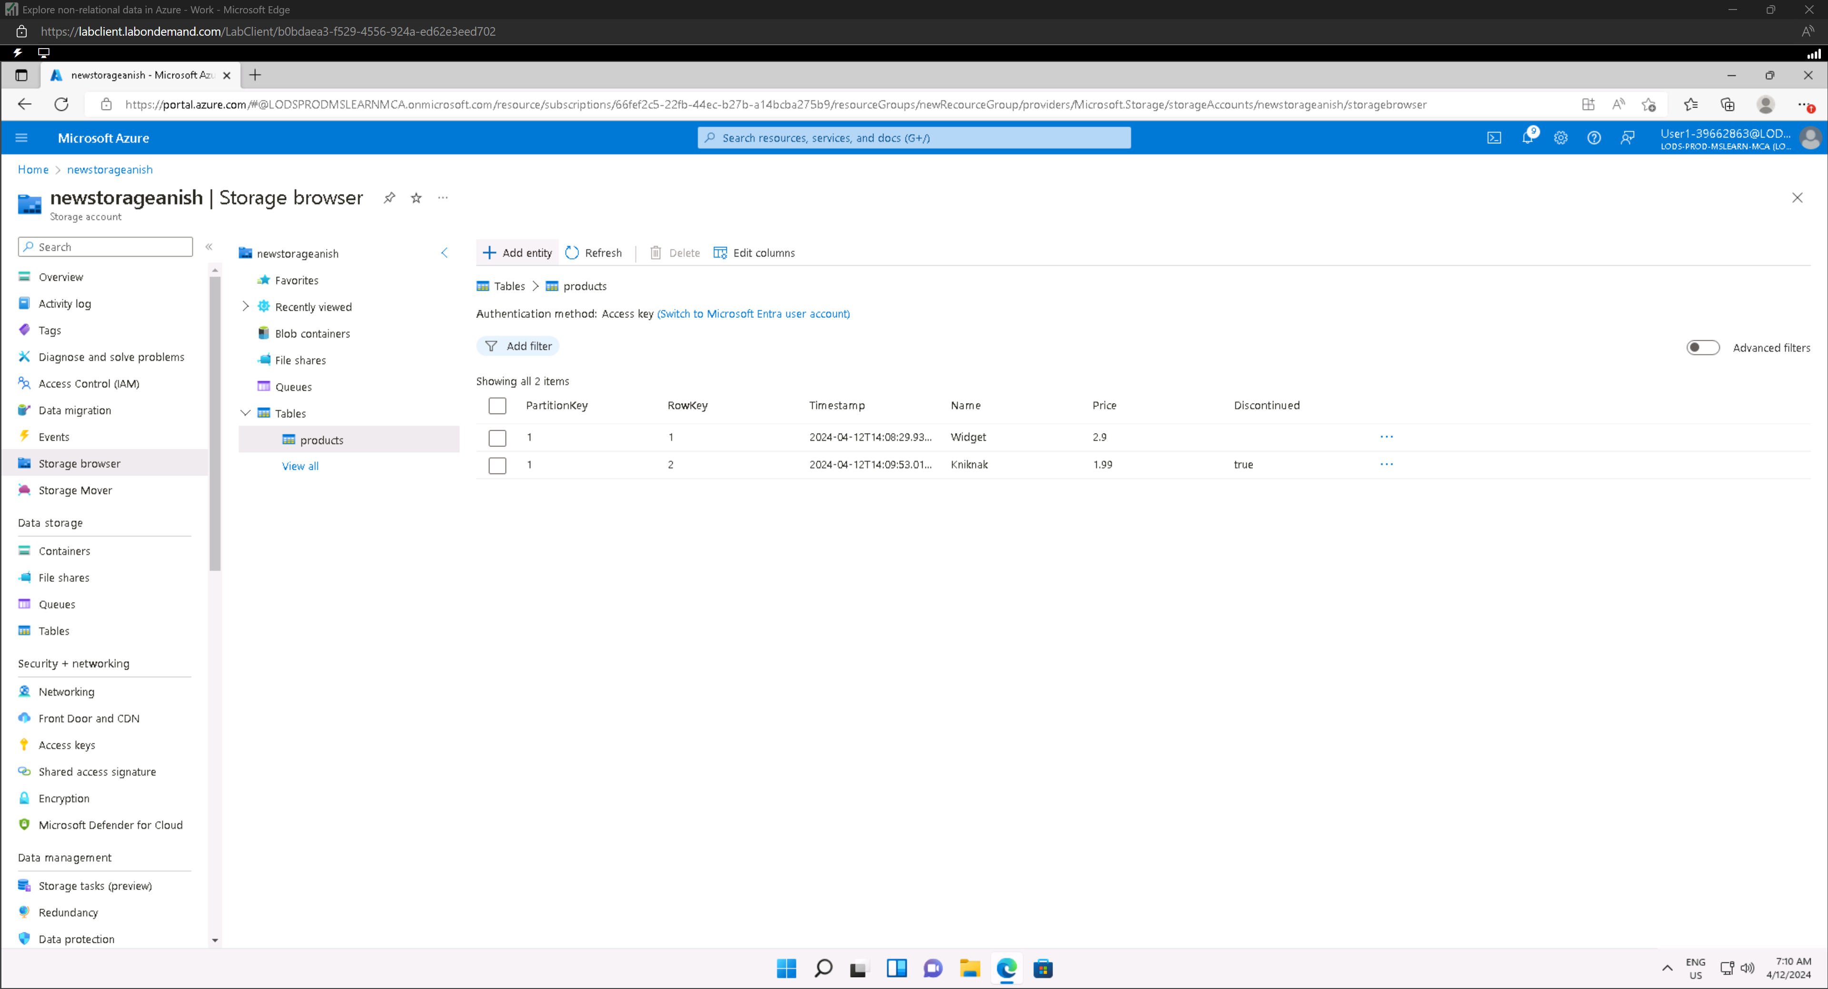

### Create a Cosmos DB account

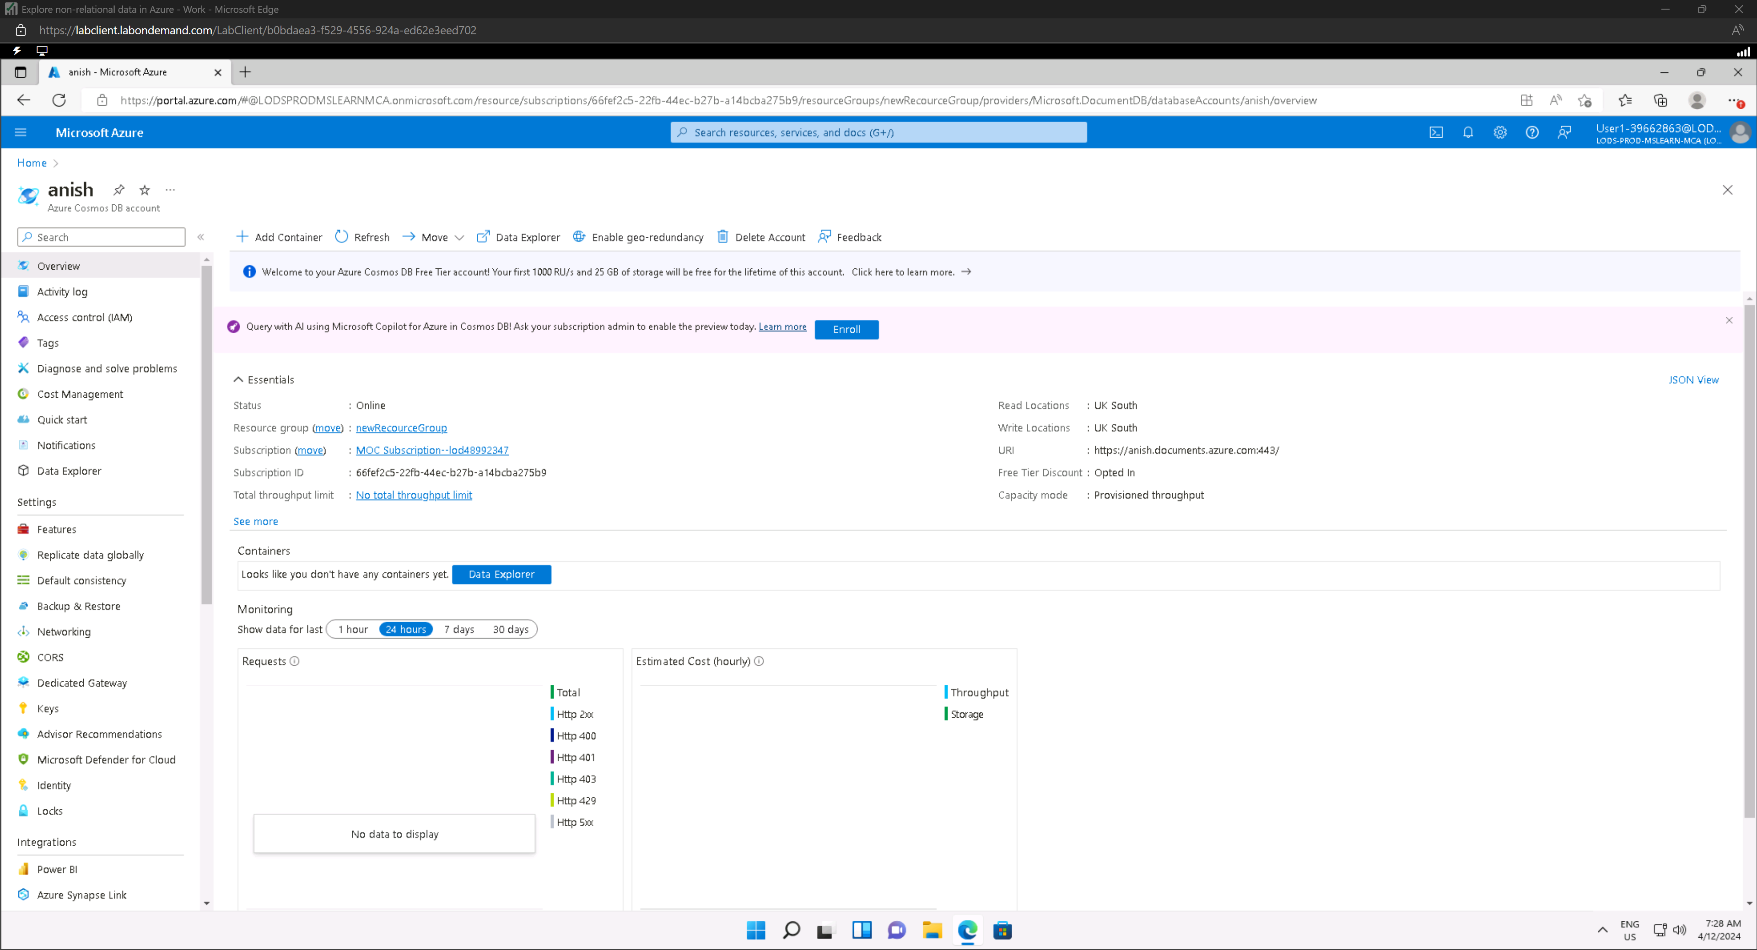

### Create a sample database

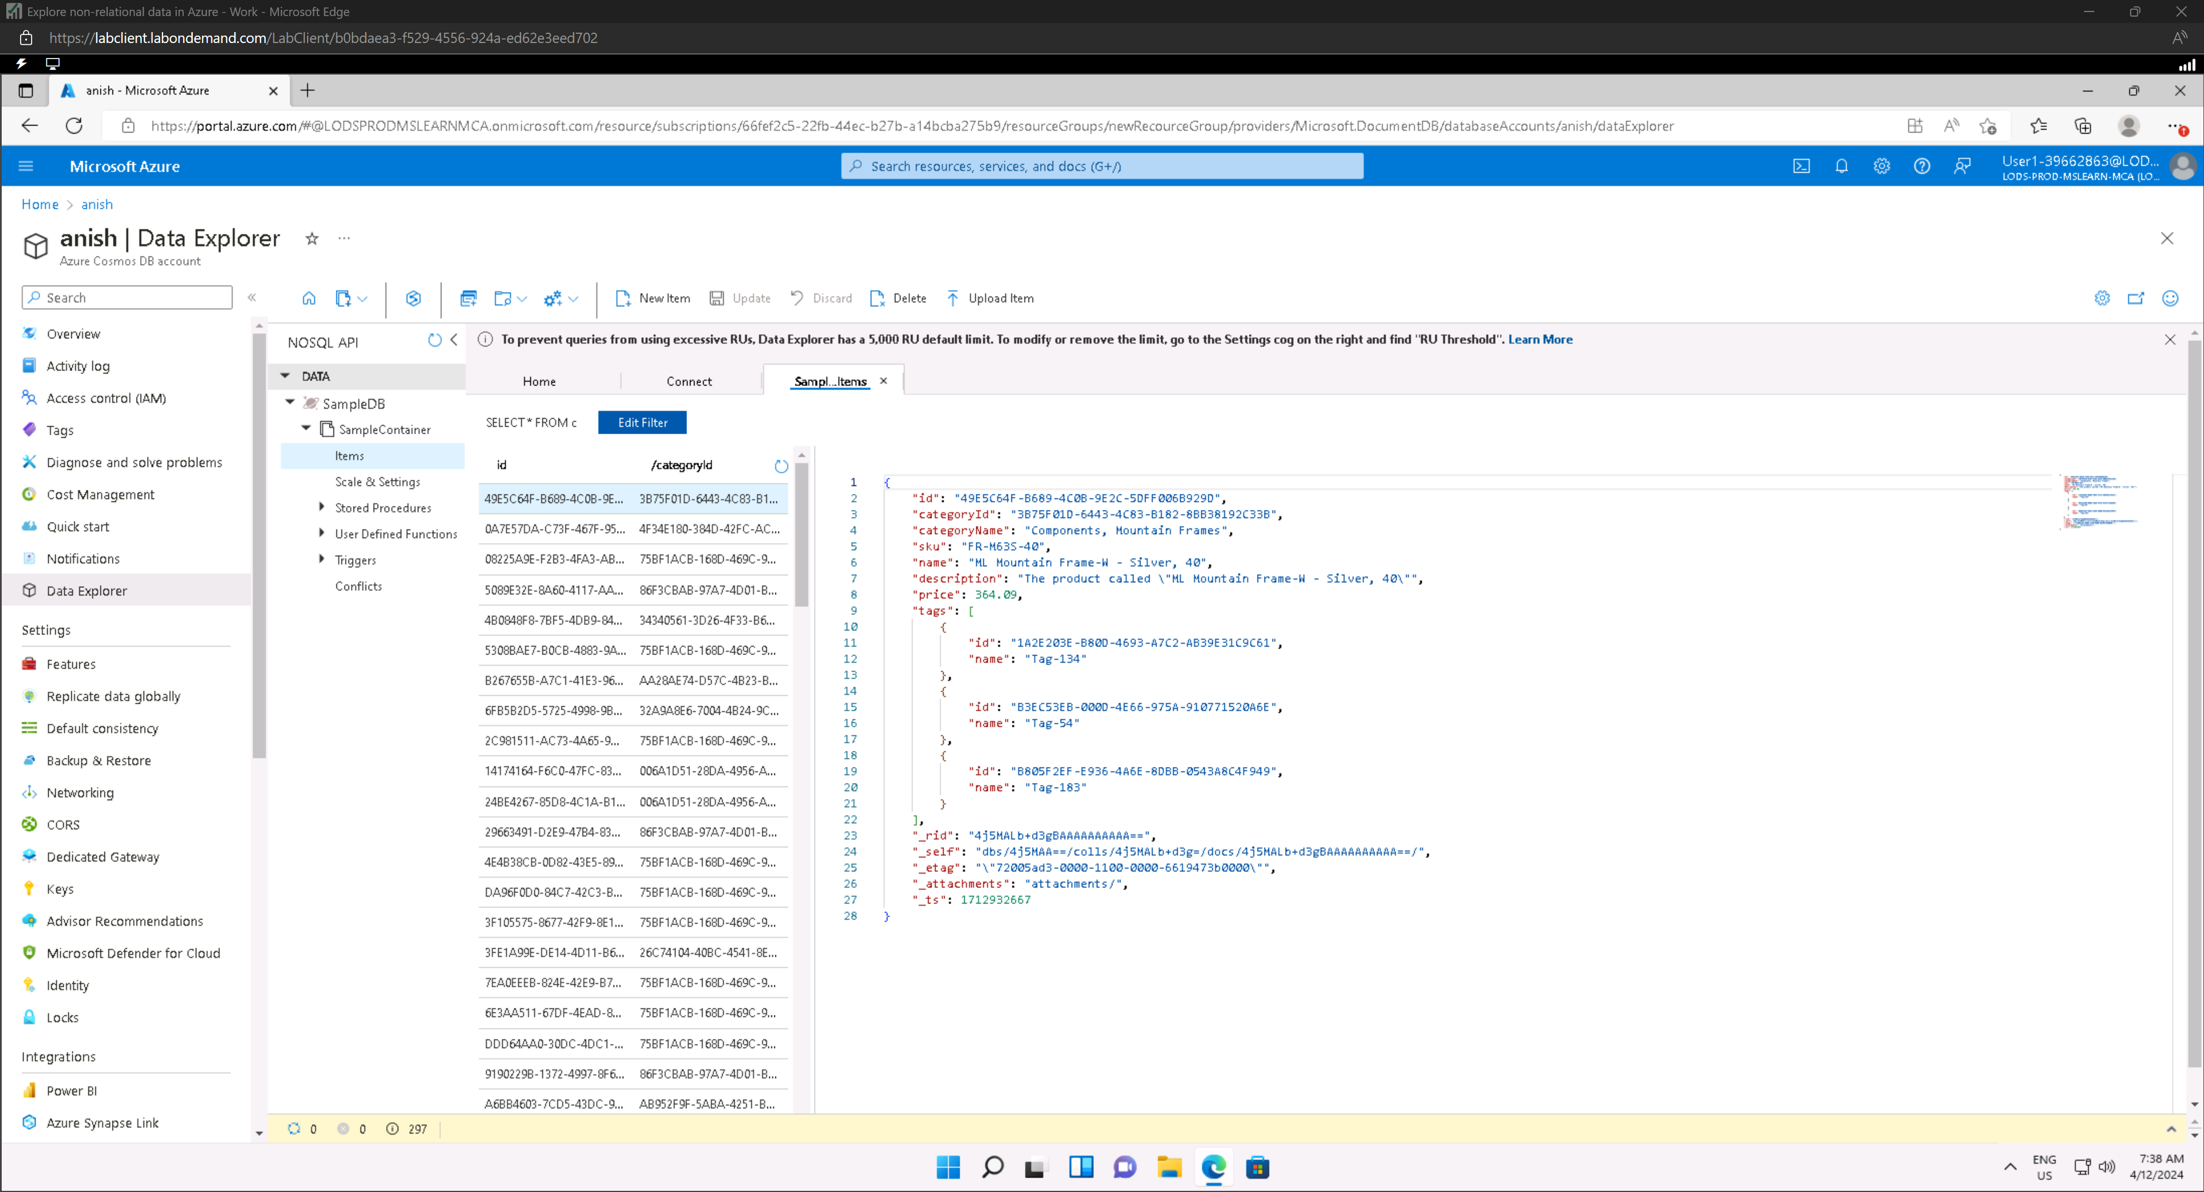

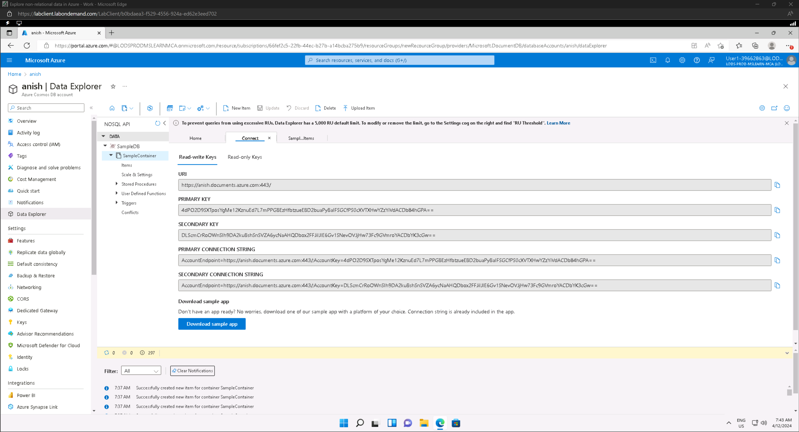

### View and create items

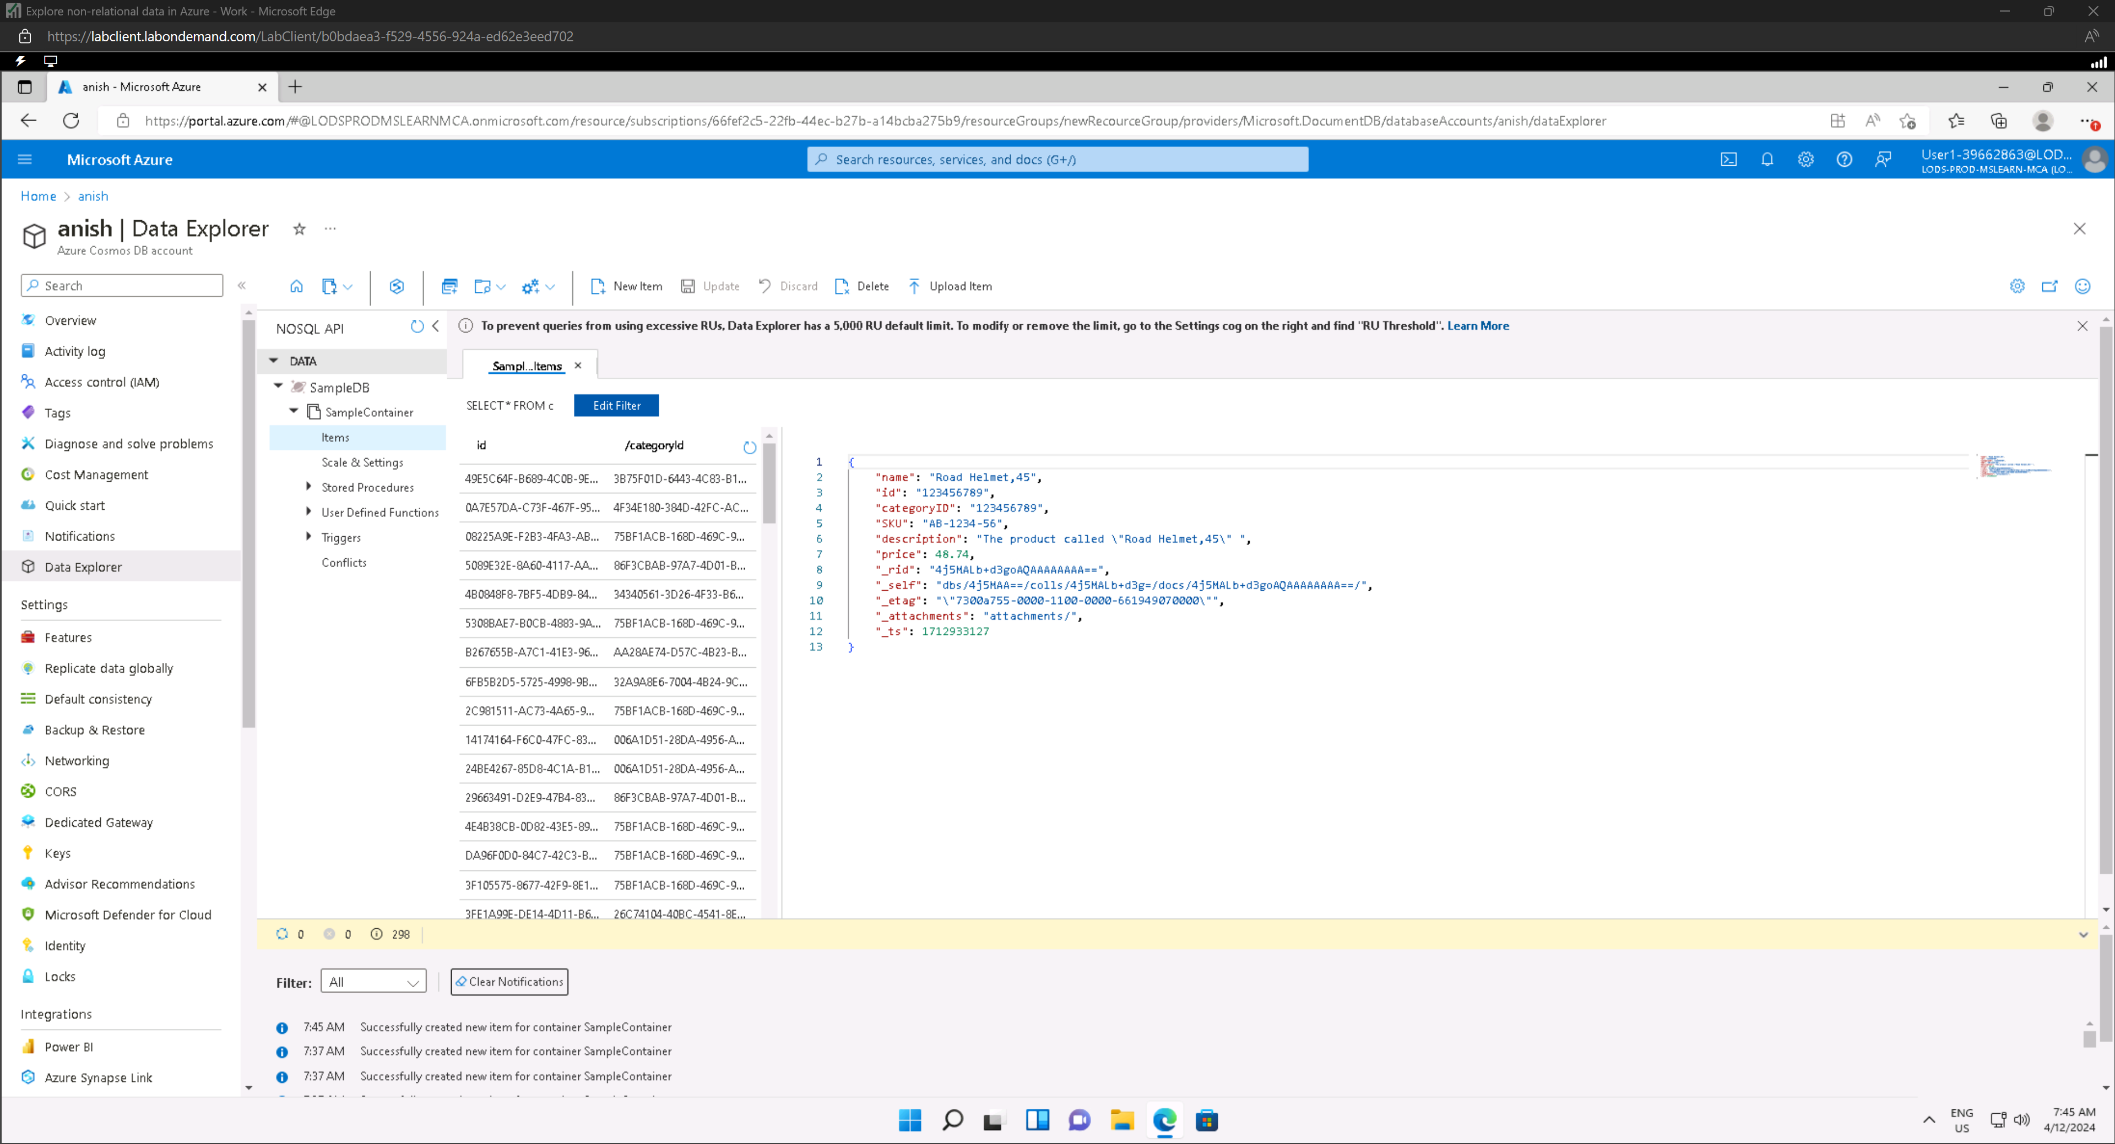

### Query the database

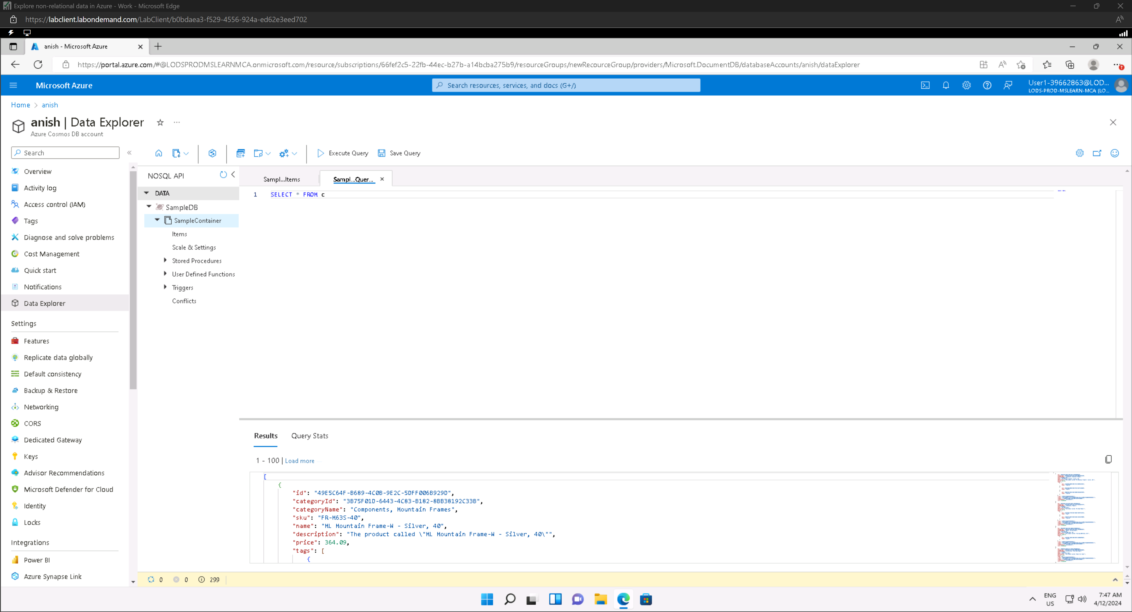

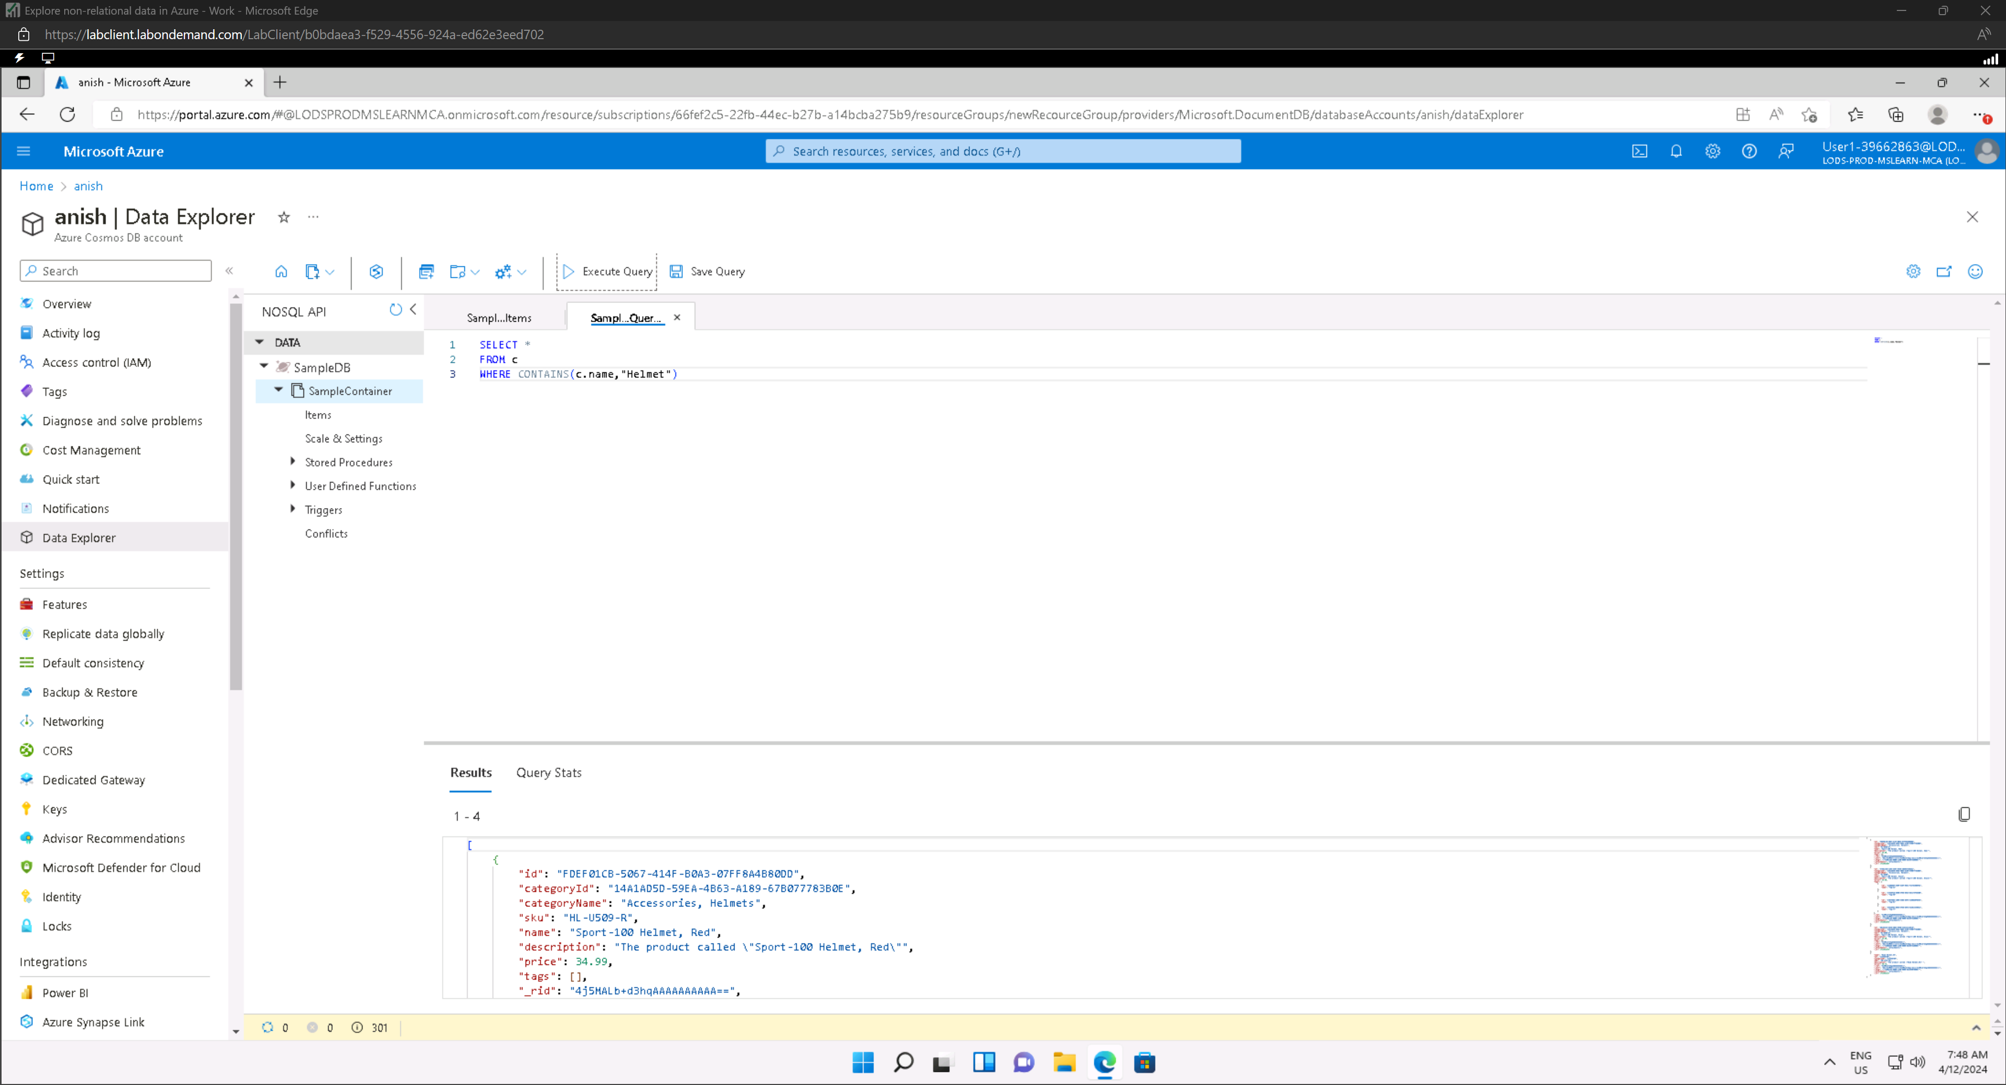

## Explore data analytics in Azure

### Create a workspace

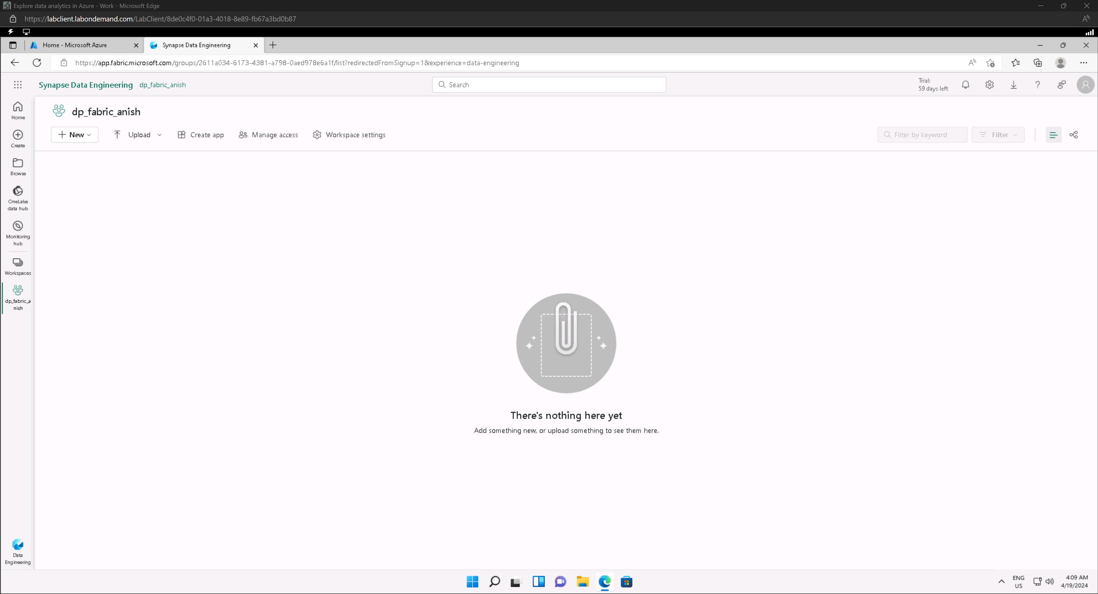

### Create a Lakehouse

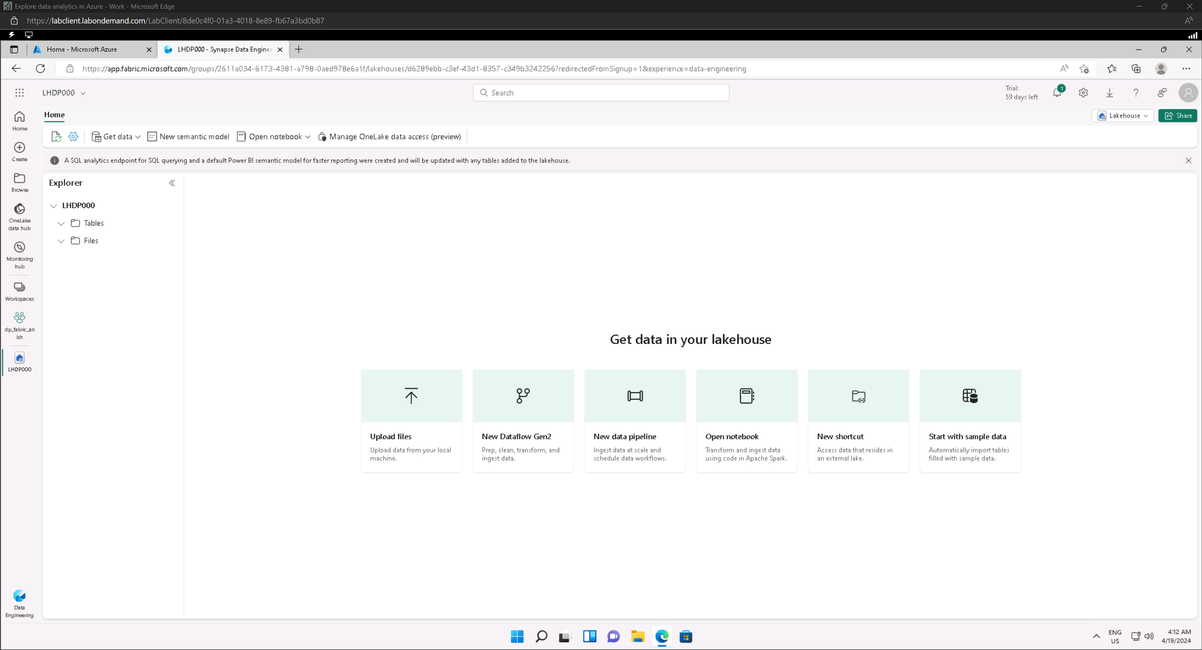

### Ingest data

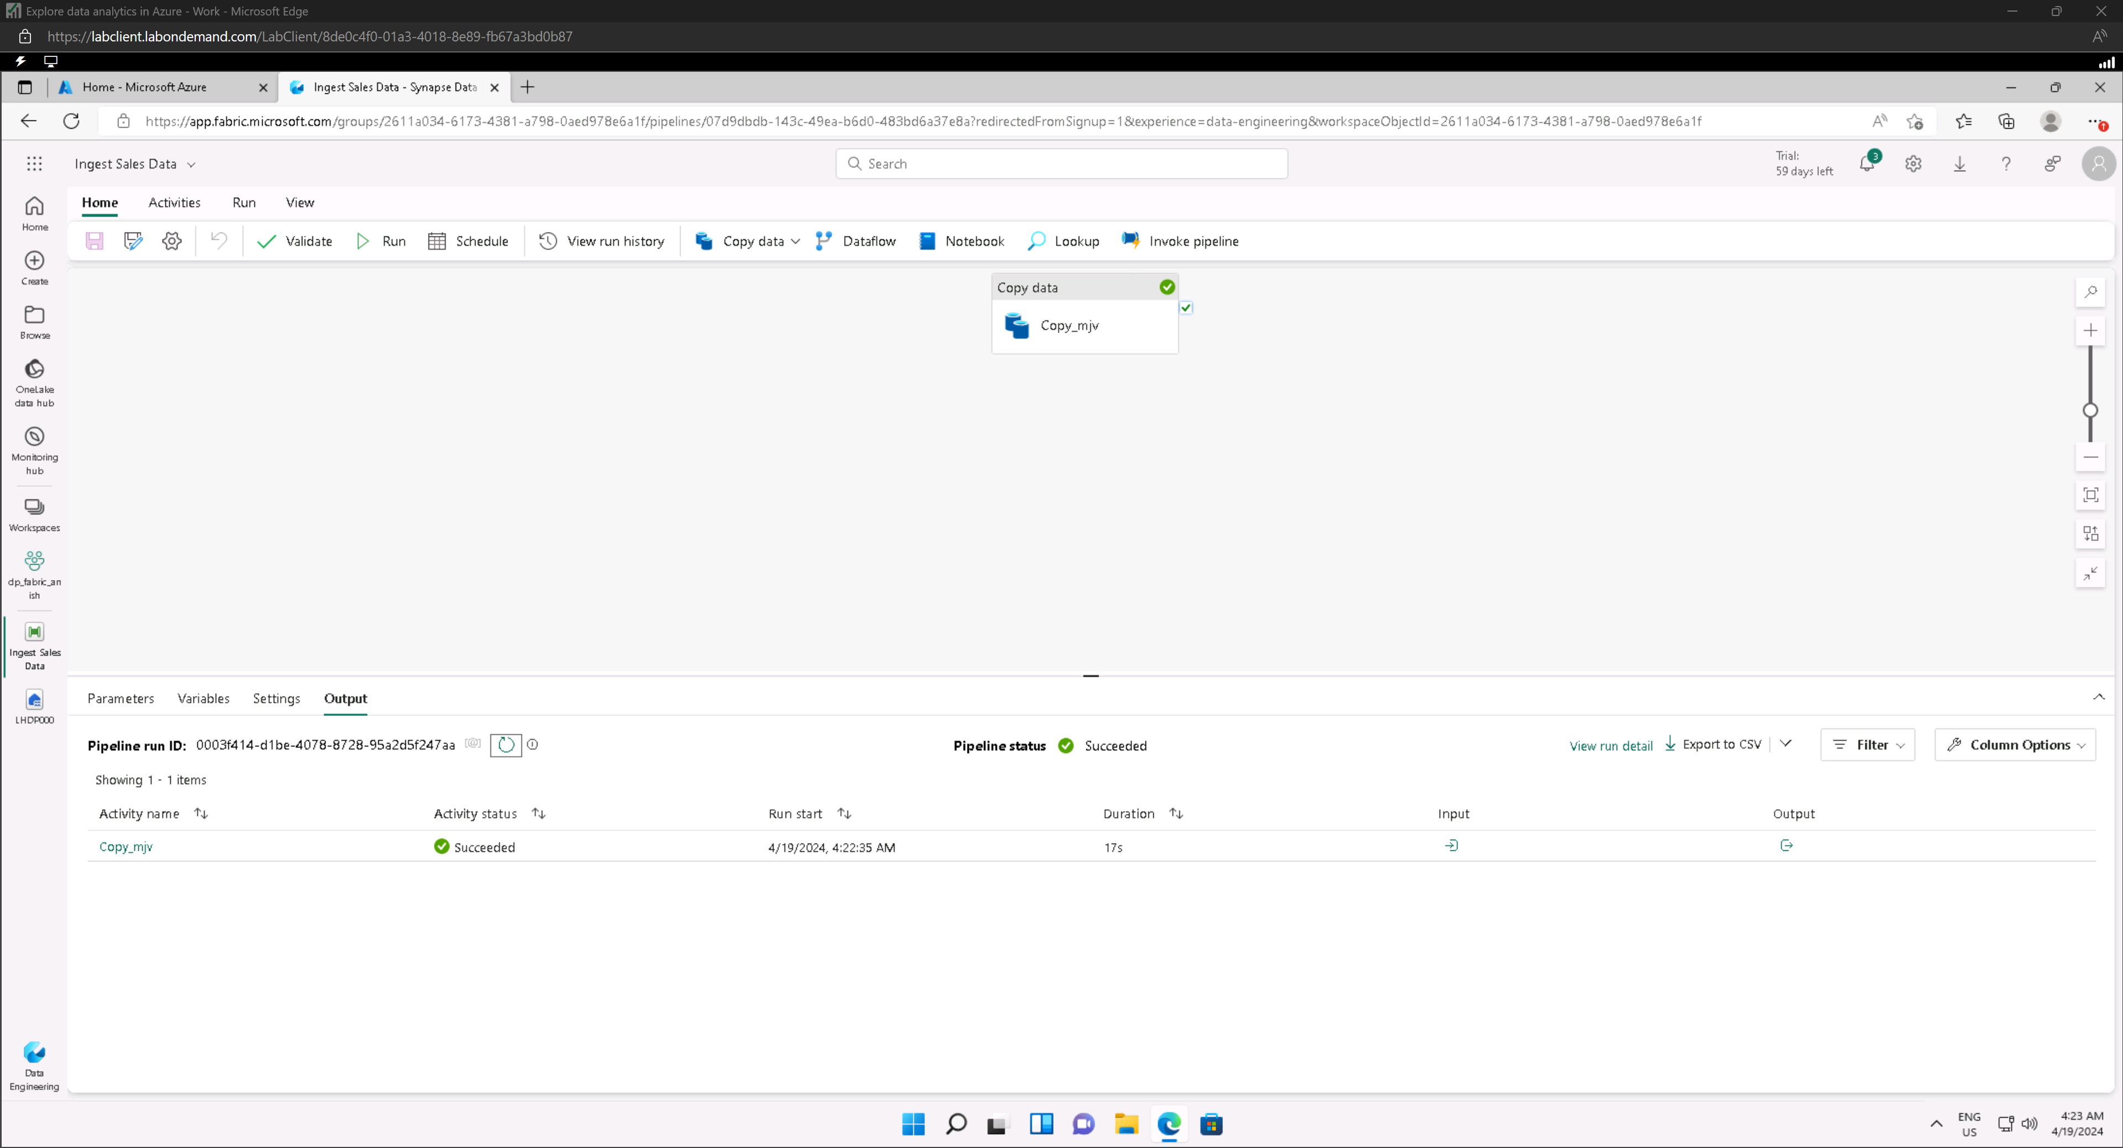

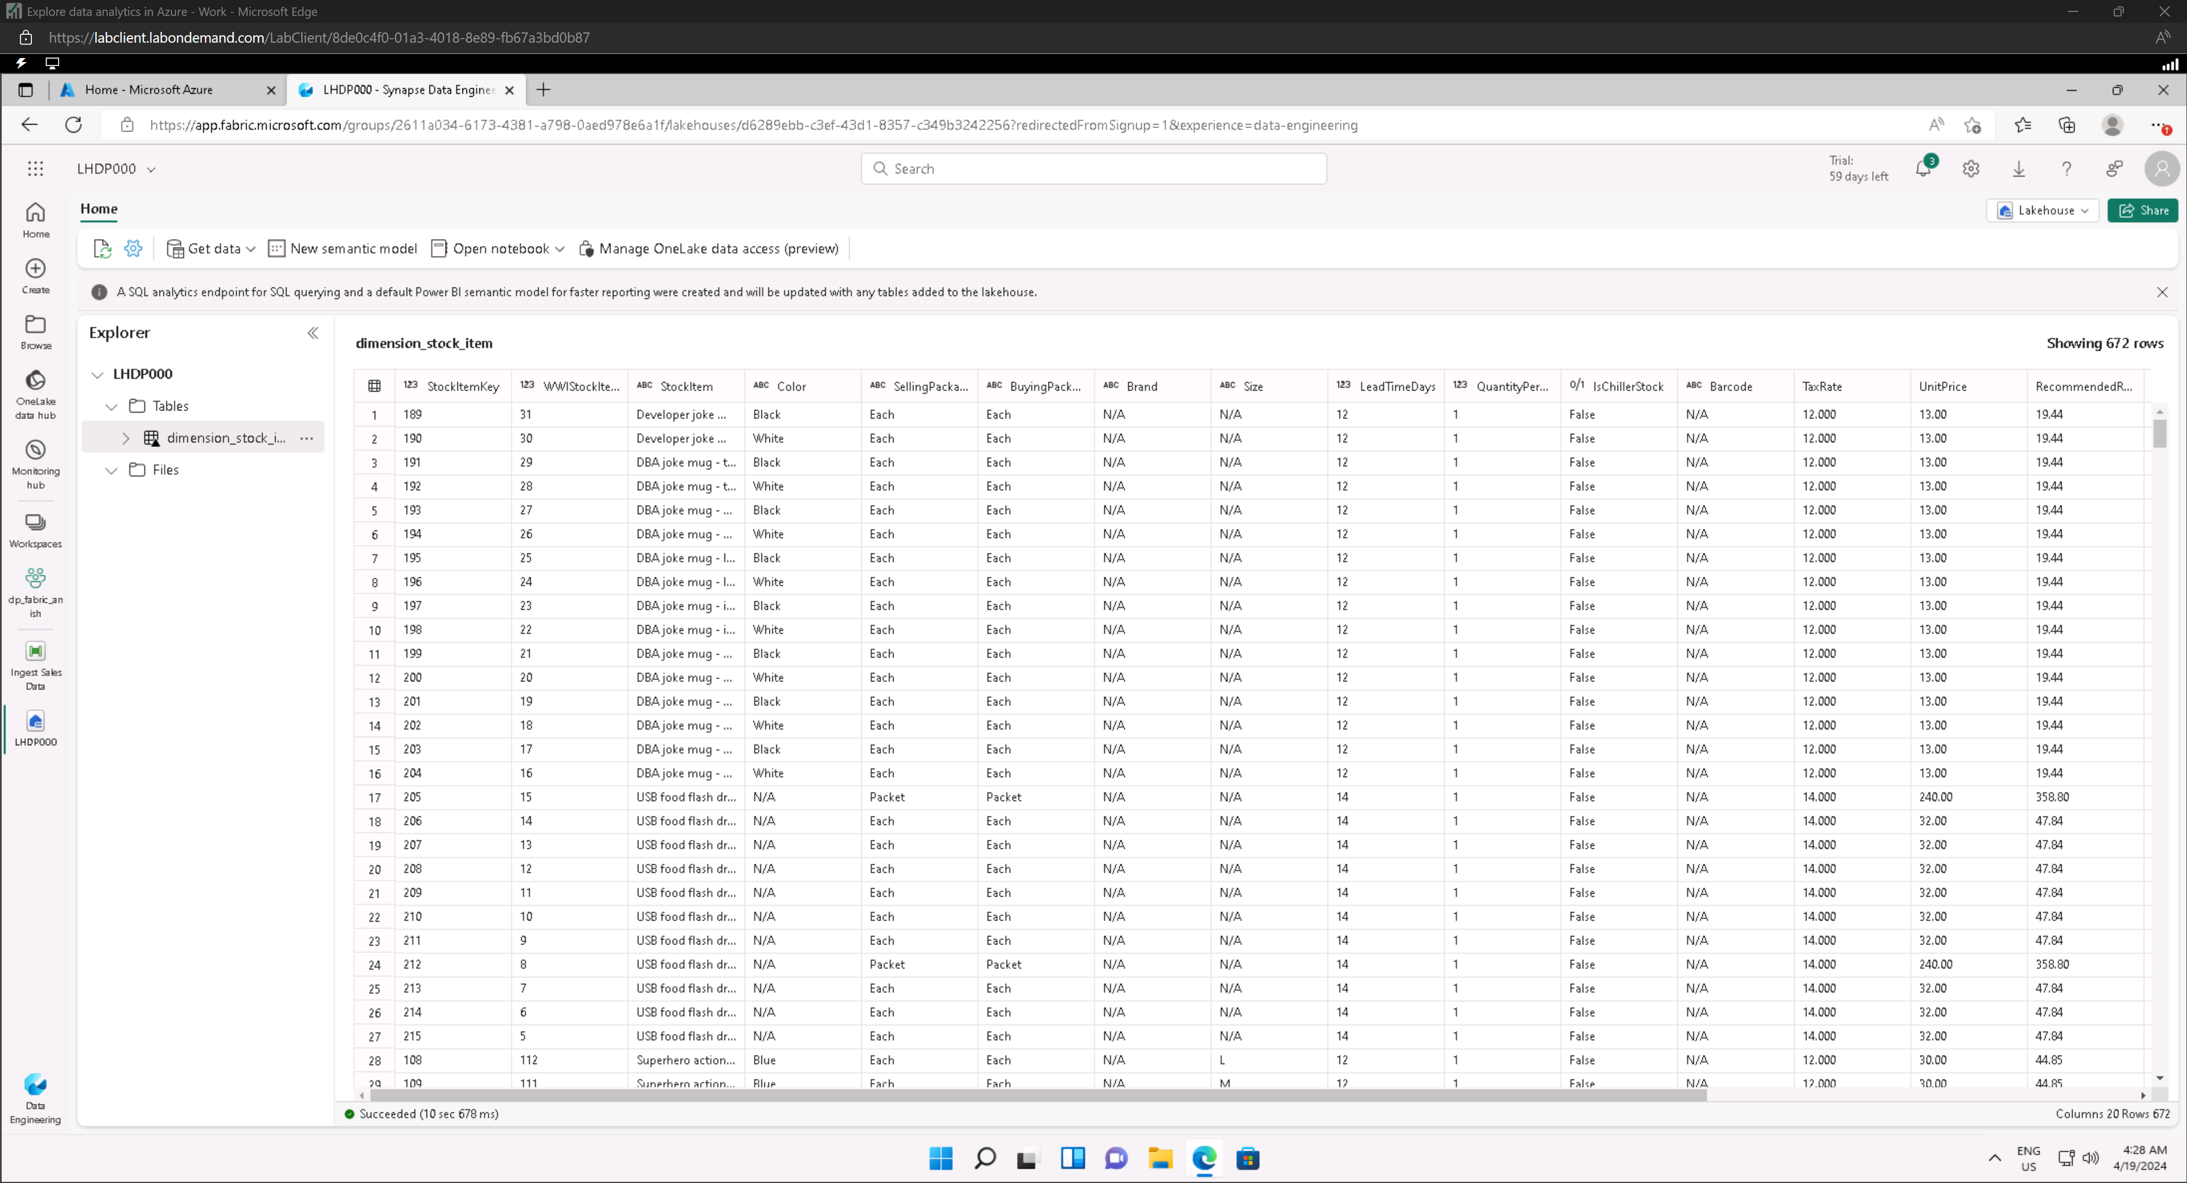

### Query data in a Lakehouse

#### switch to the **SQL analytics endpoint**

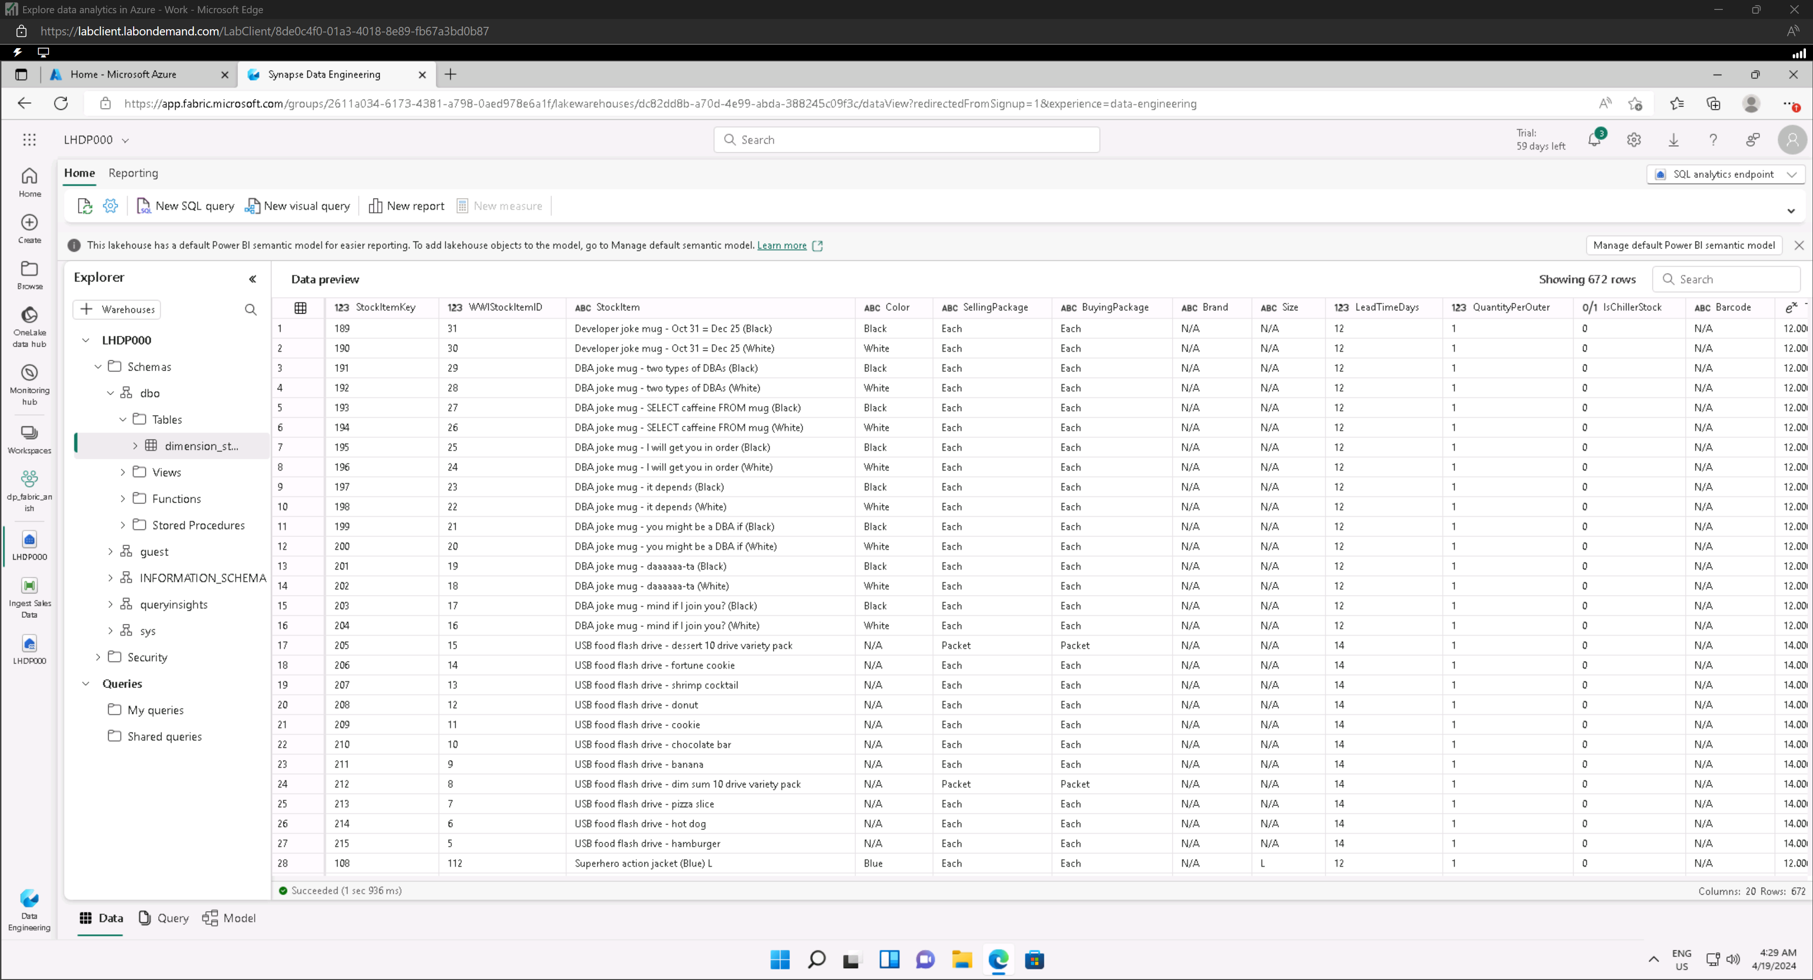

#### New SQL query

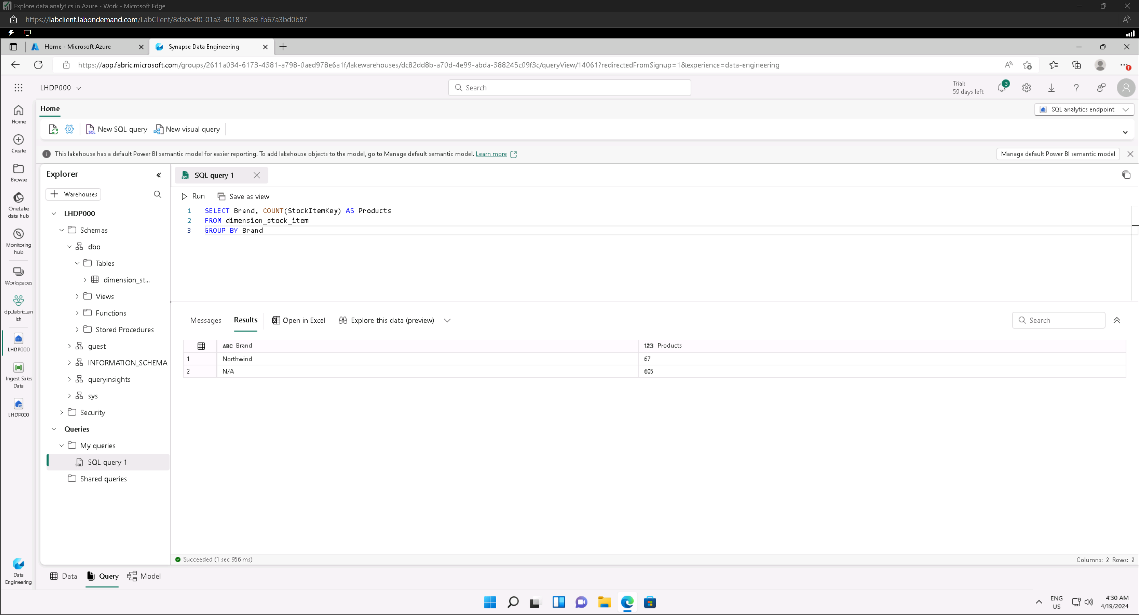

### Visualize data in a Lakehouse

#### Model view

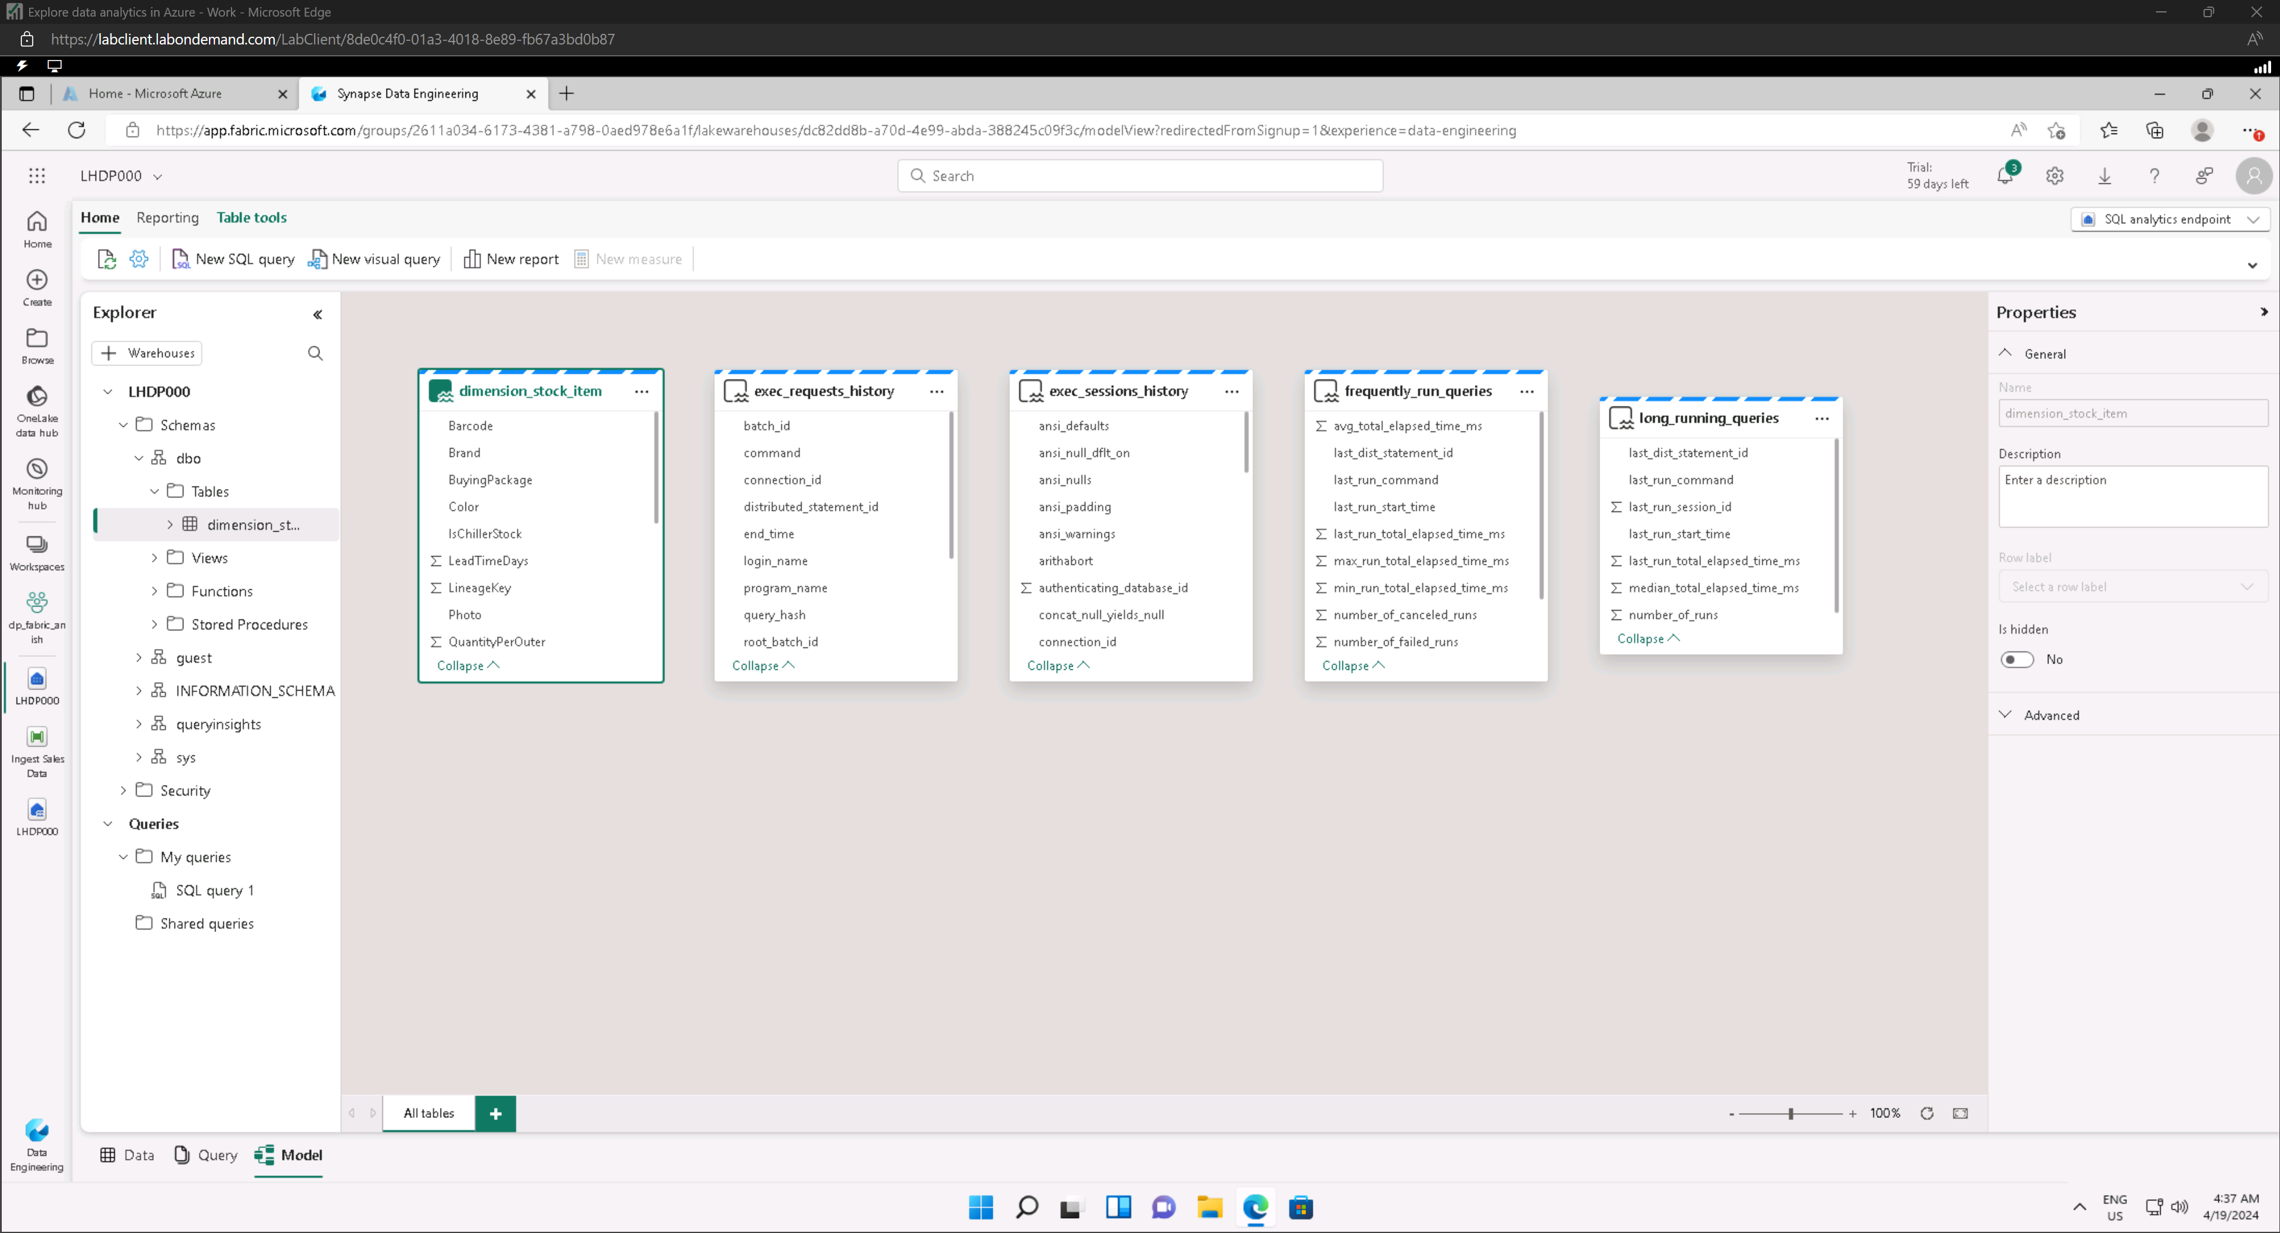

#### Report designer

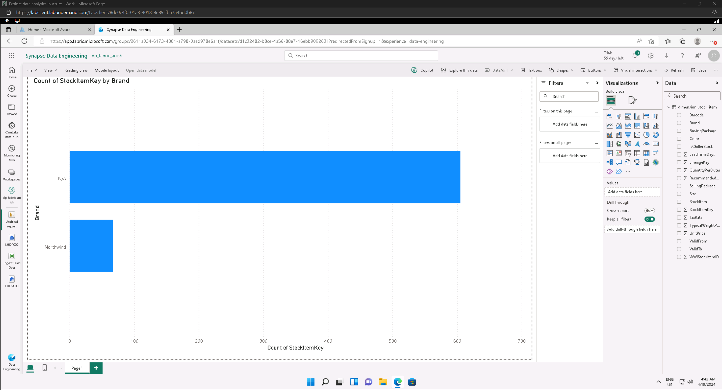

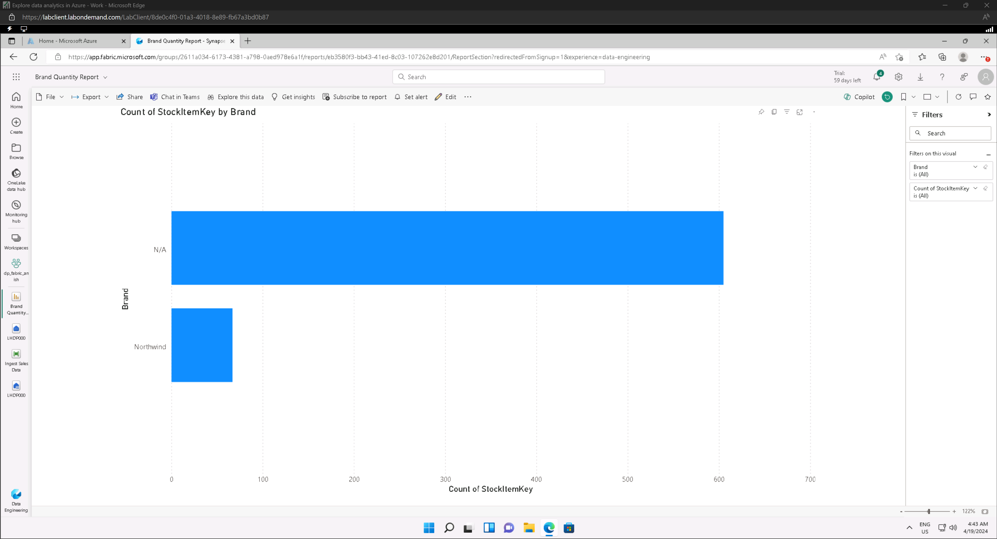

## Explore real-time analytics in Microsoft Fabric

### Create a workspace

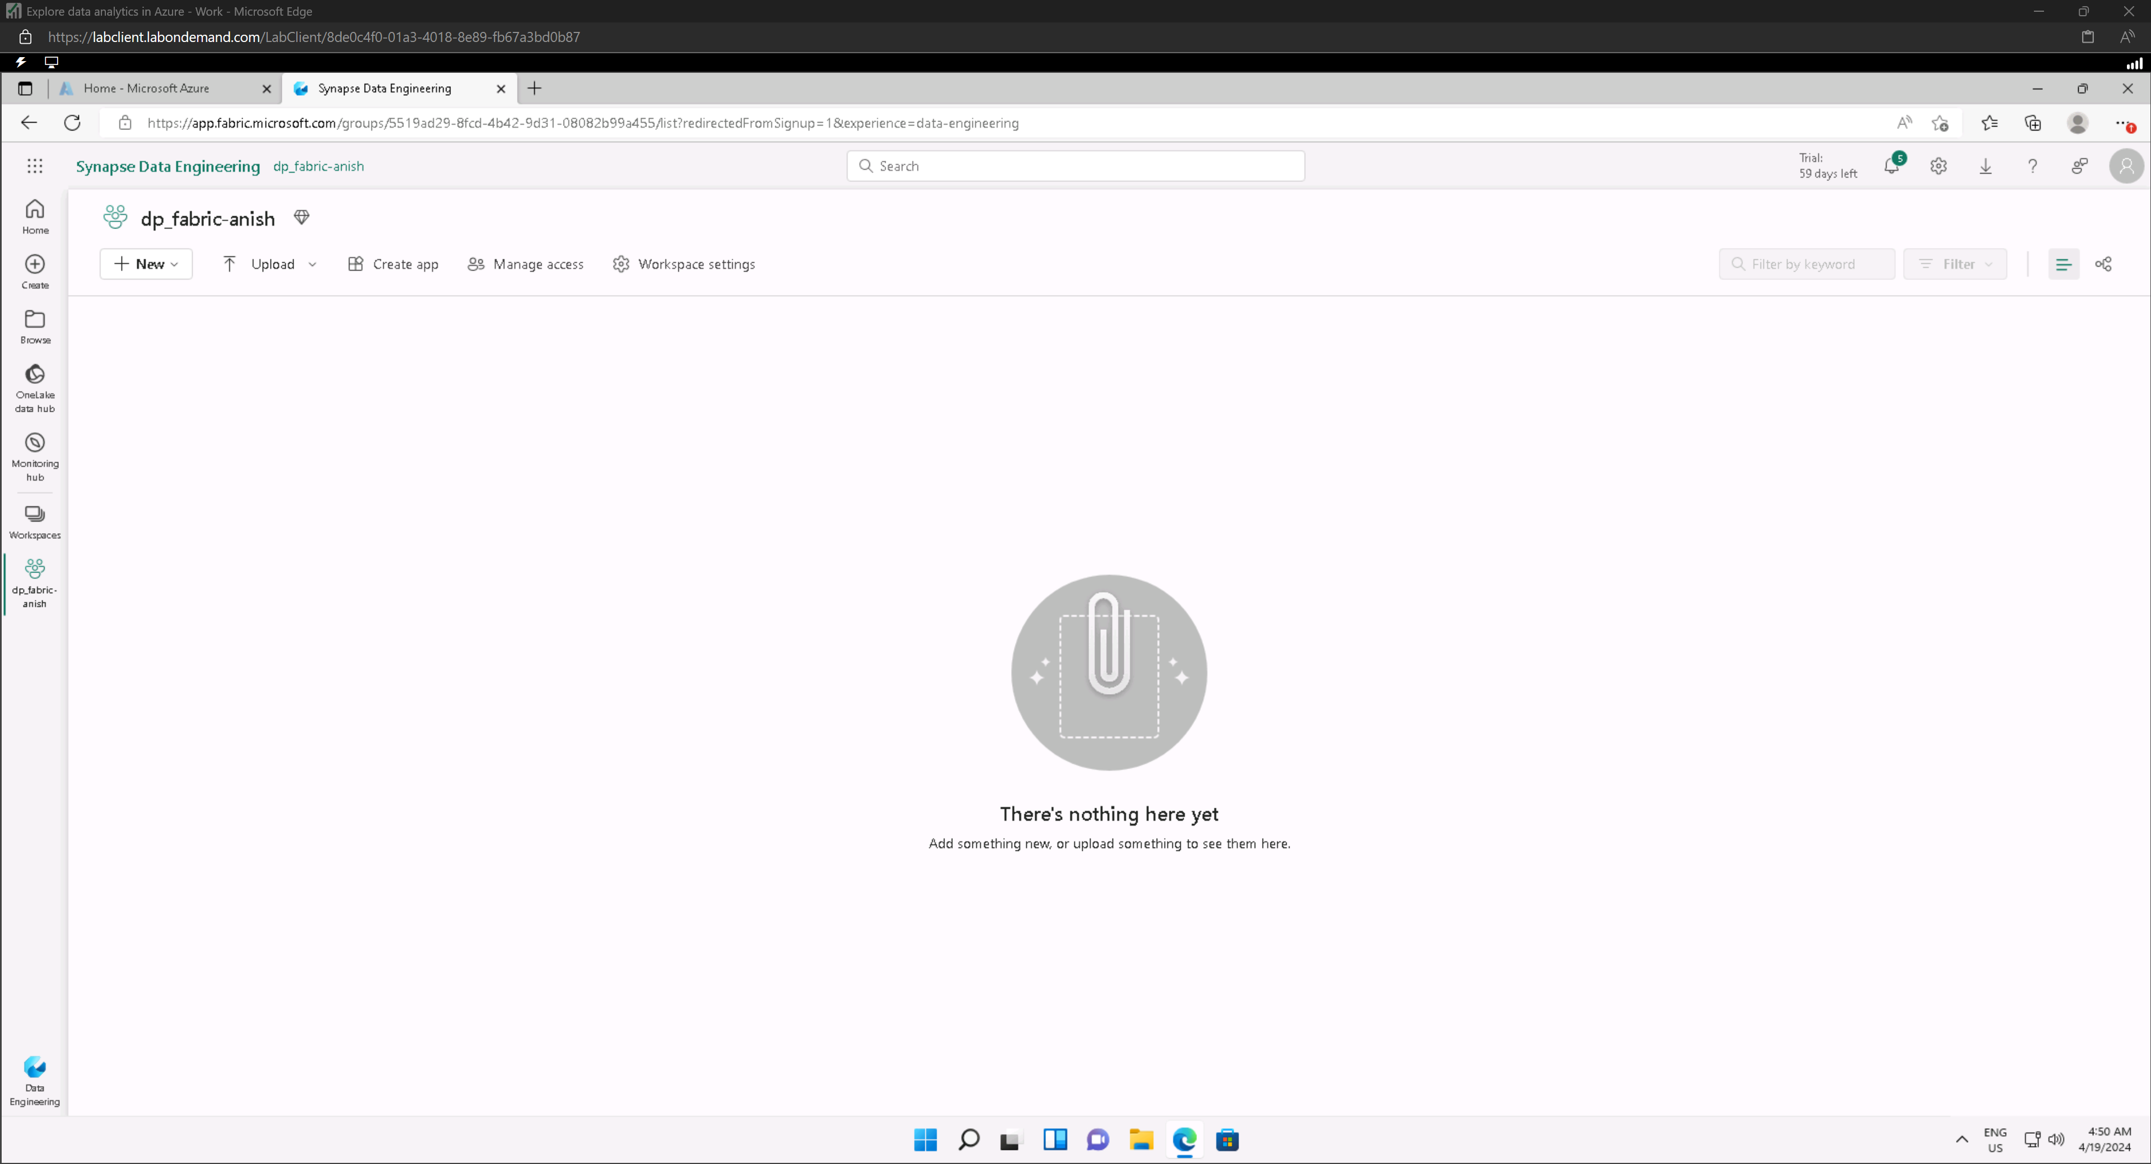

### Create a KQL database

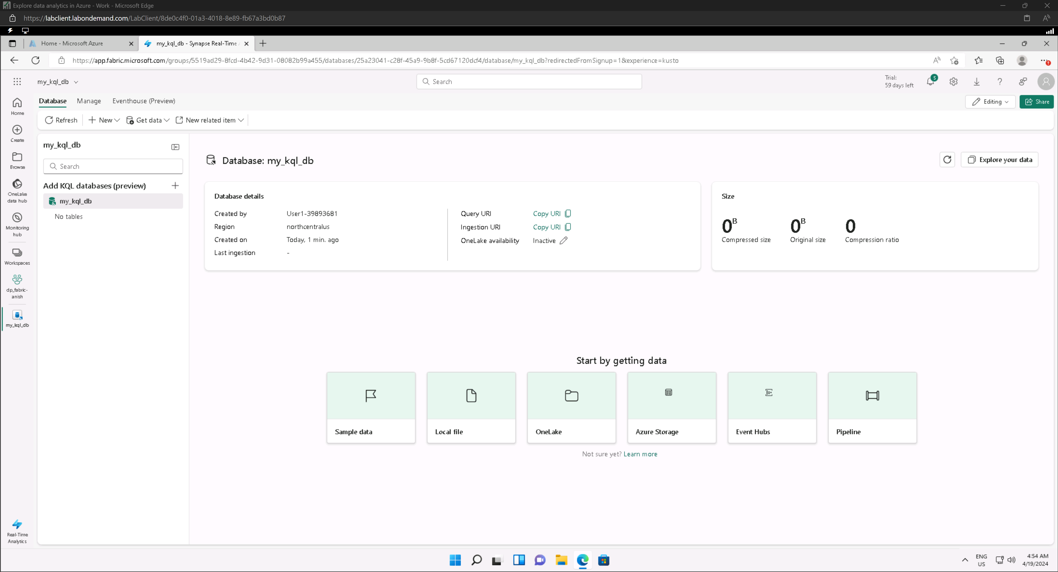

### Create an eventstream

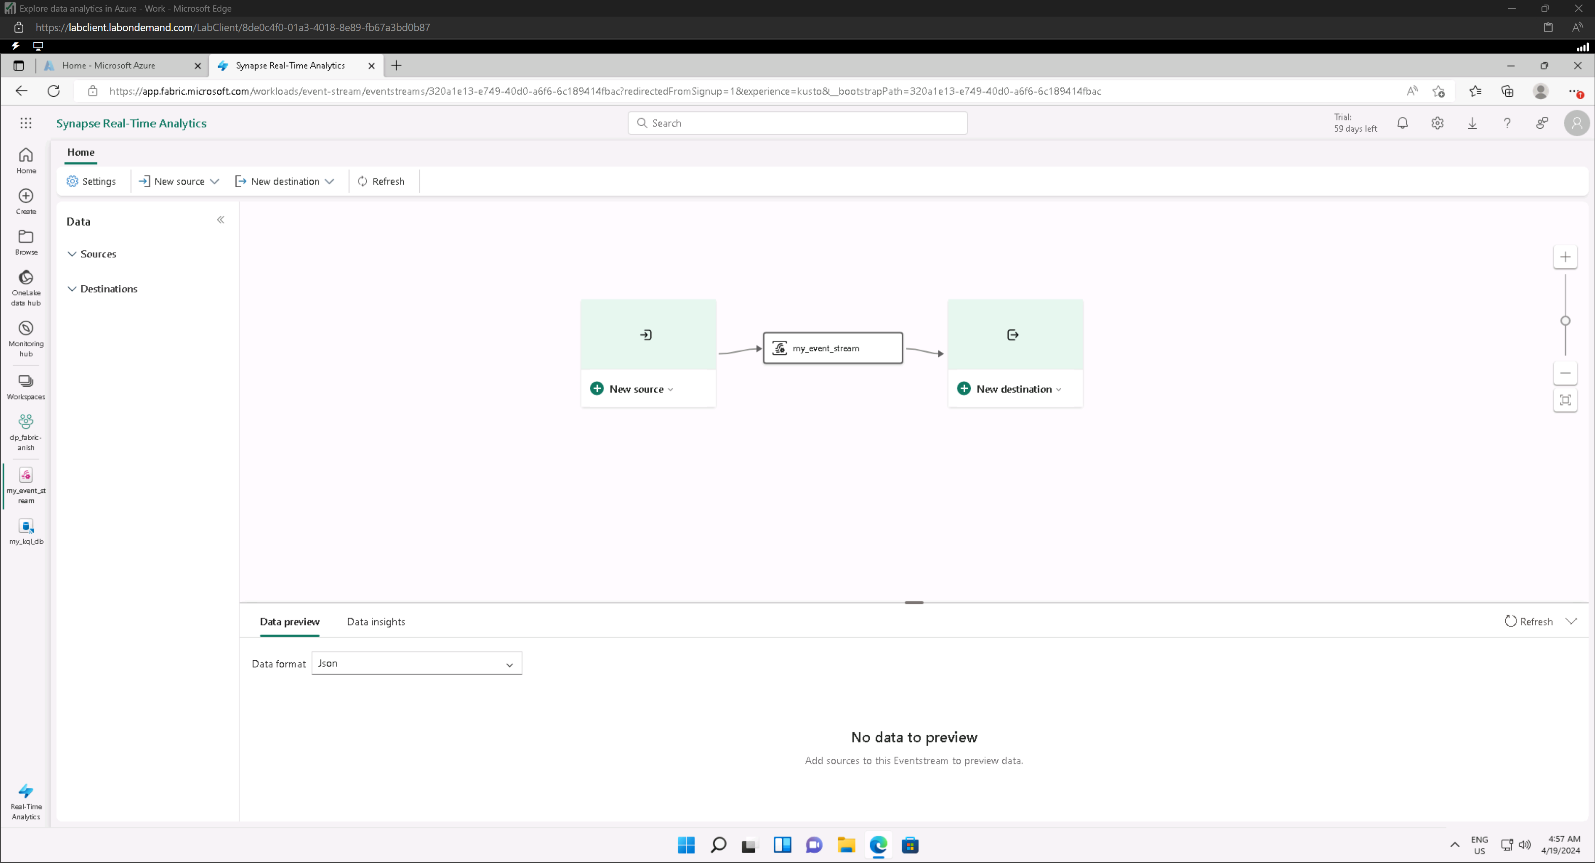

#### Add new source

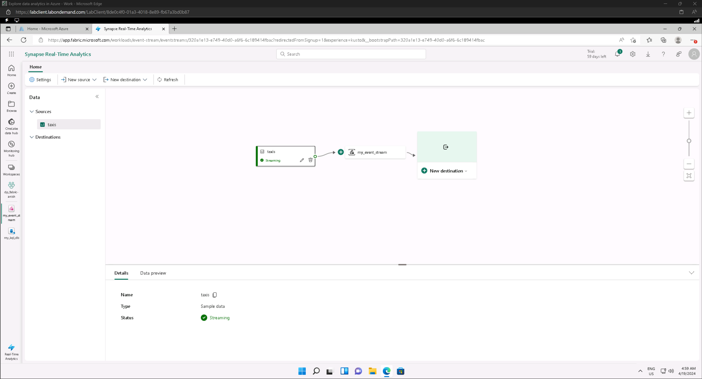

#### Preview data

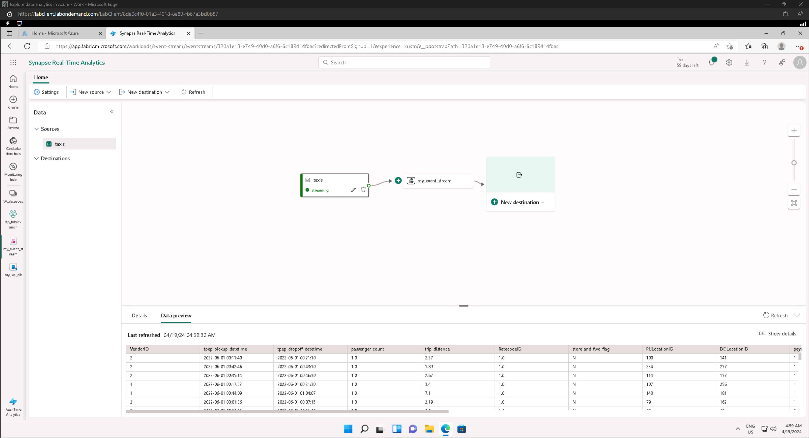

#### Add new destination

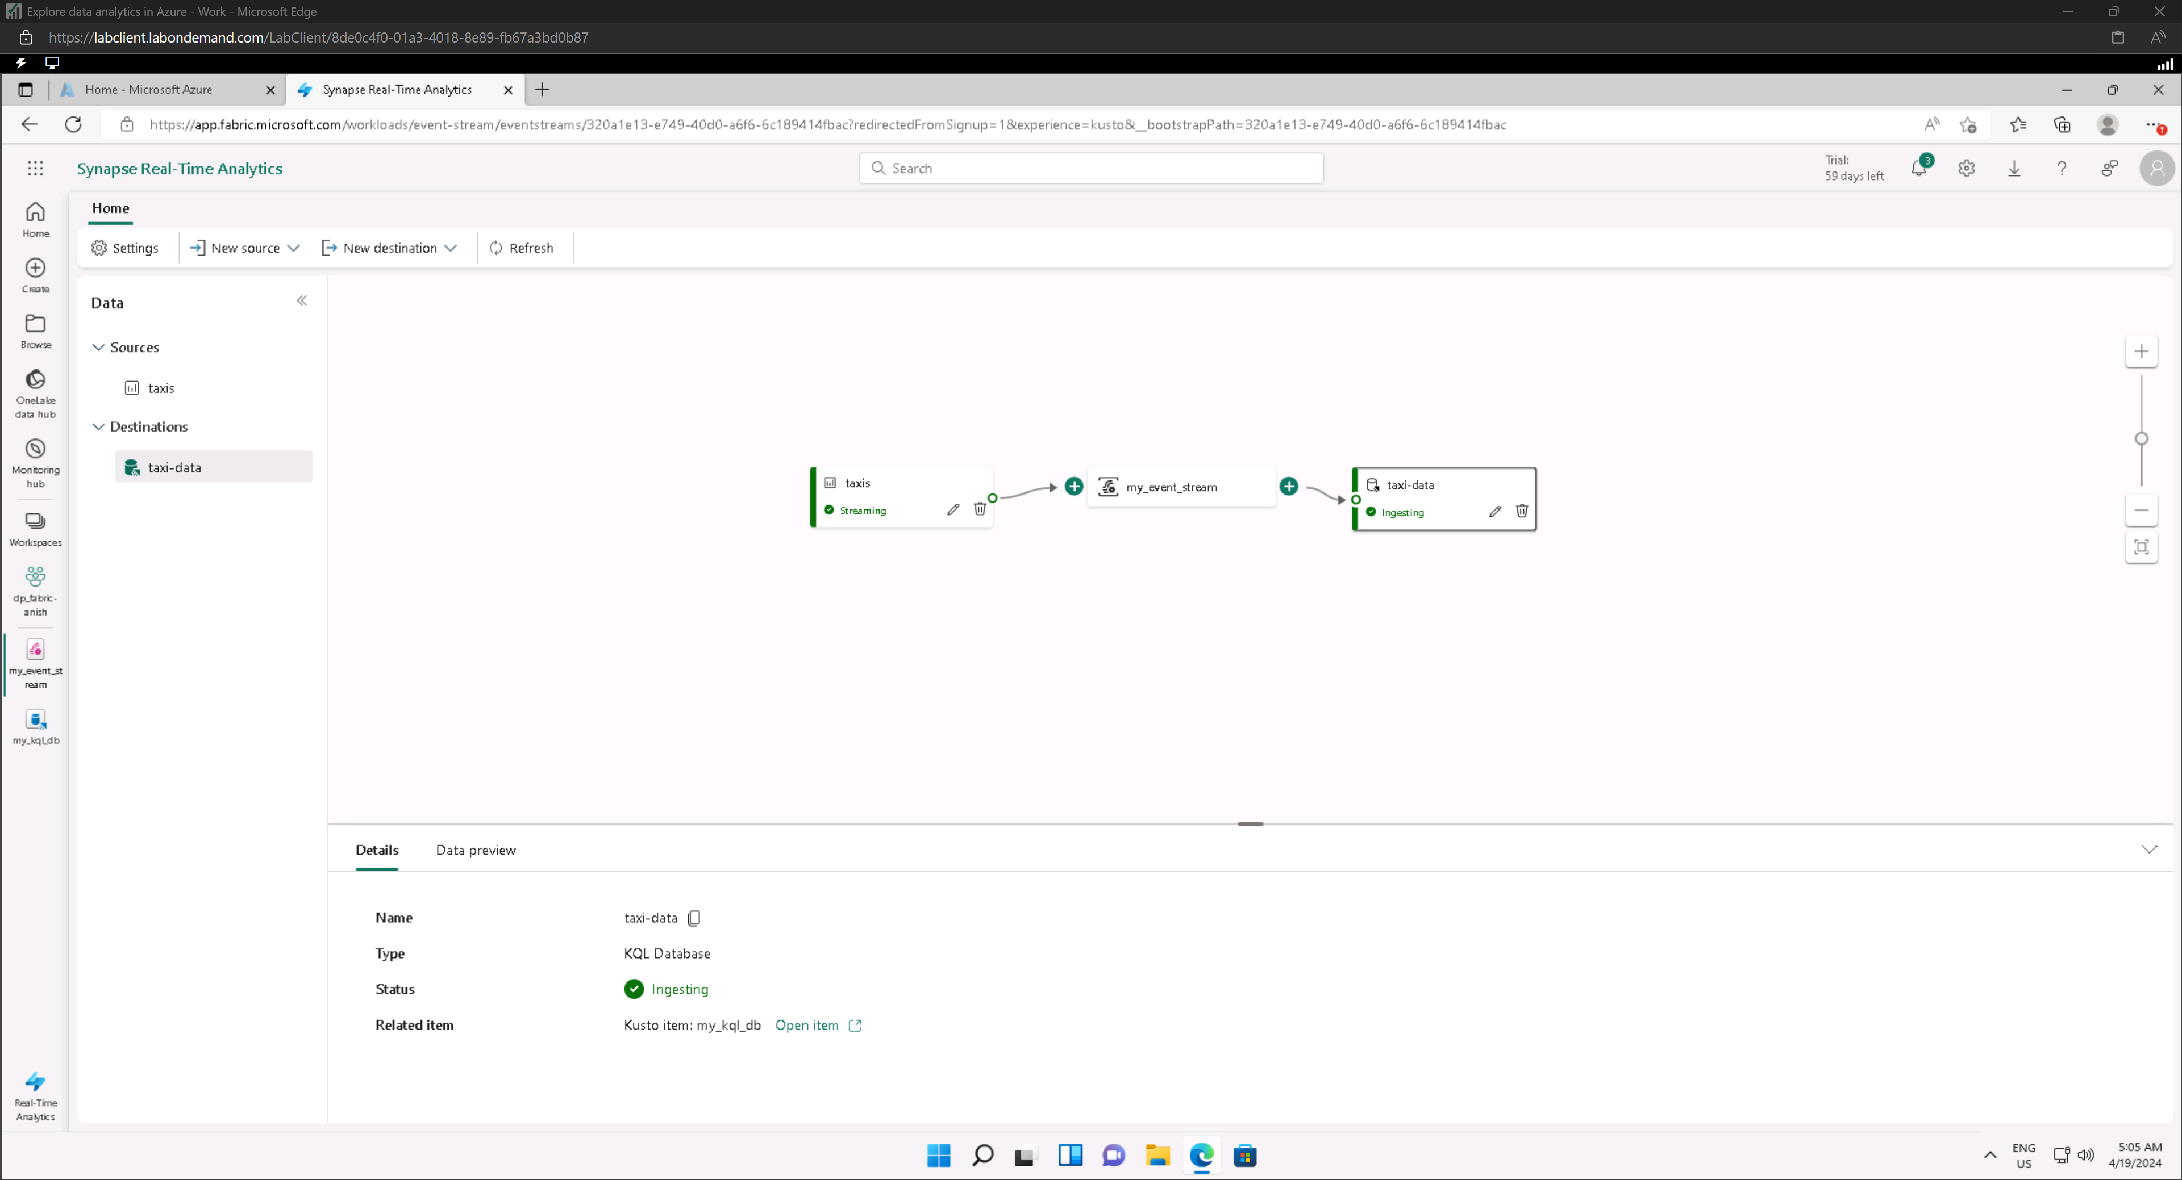

### Query real-time data in a KQL database

#### show all taxi records ingested from the streaming source in the last 24 hours

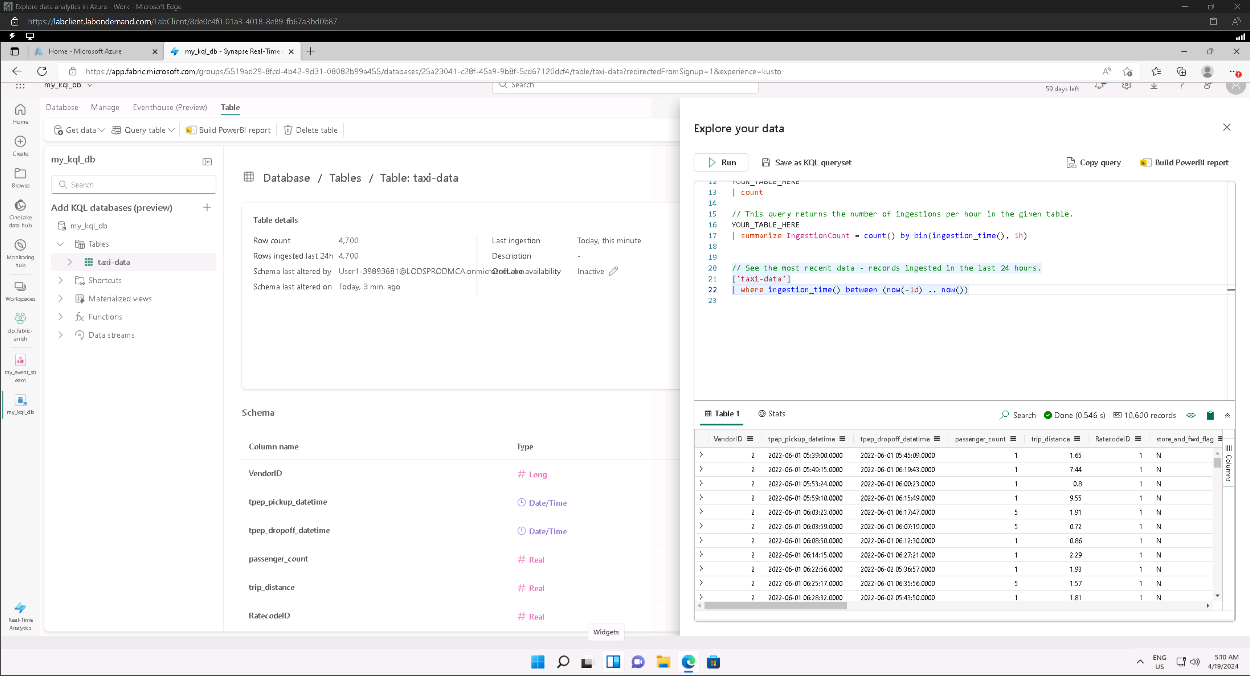

#### show the number of taxi pickups for each hour

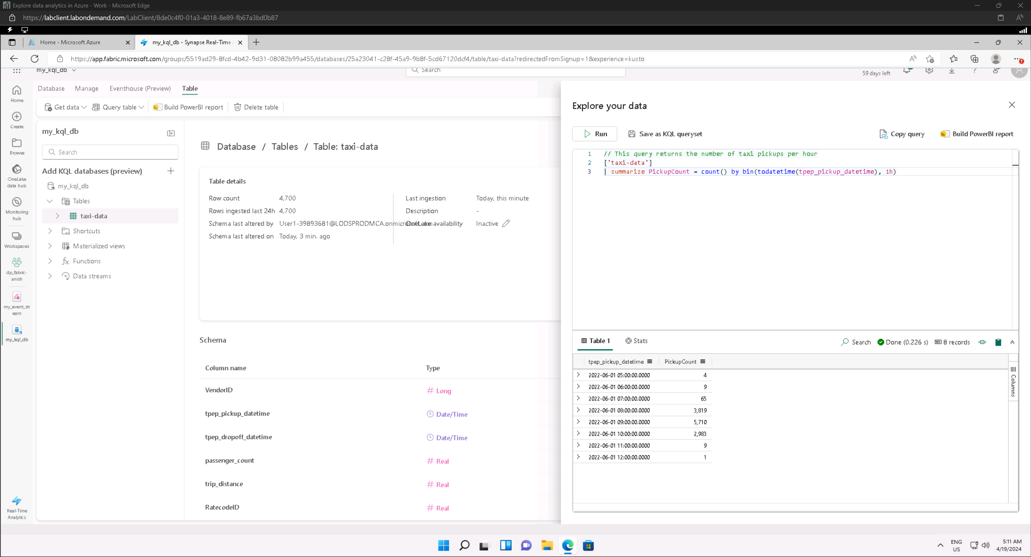

## Explore fundamentals of data visualization with Power BI

### Import Data

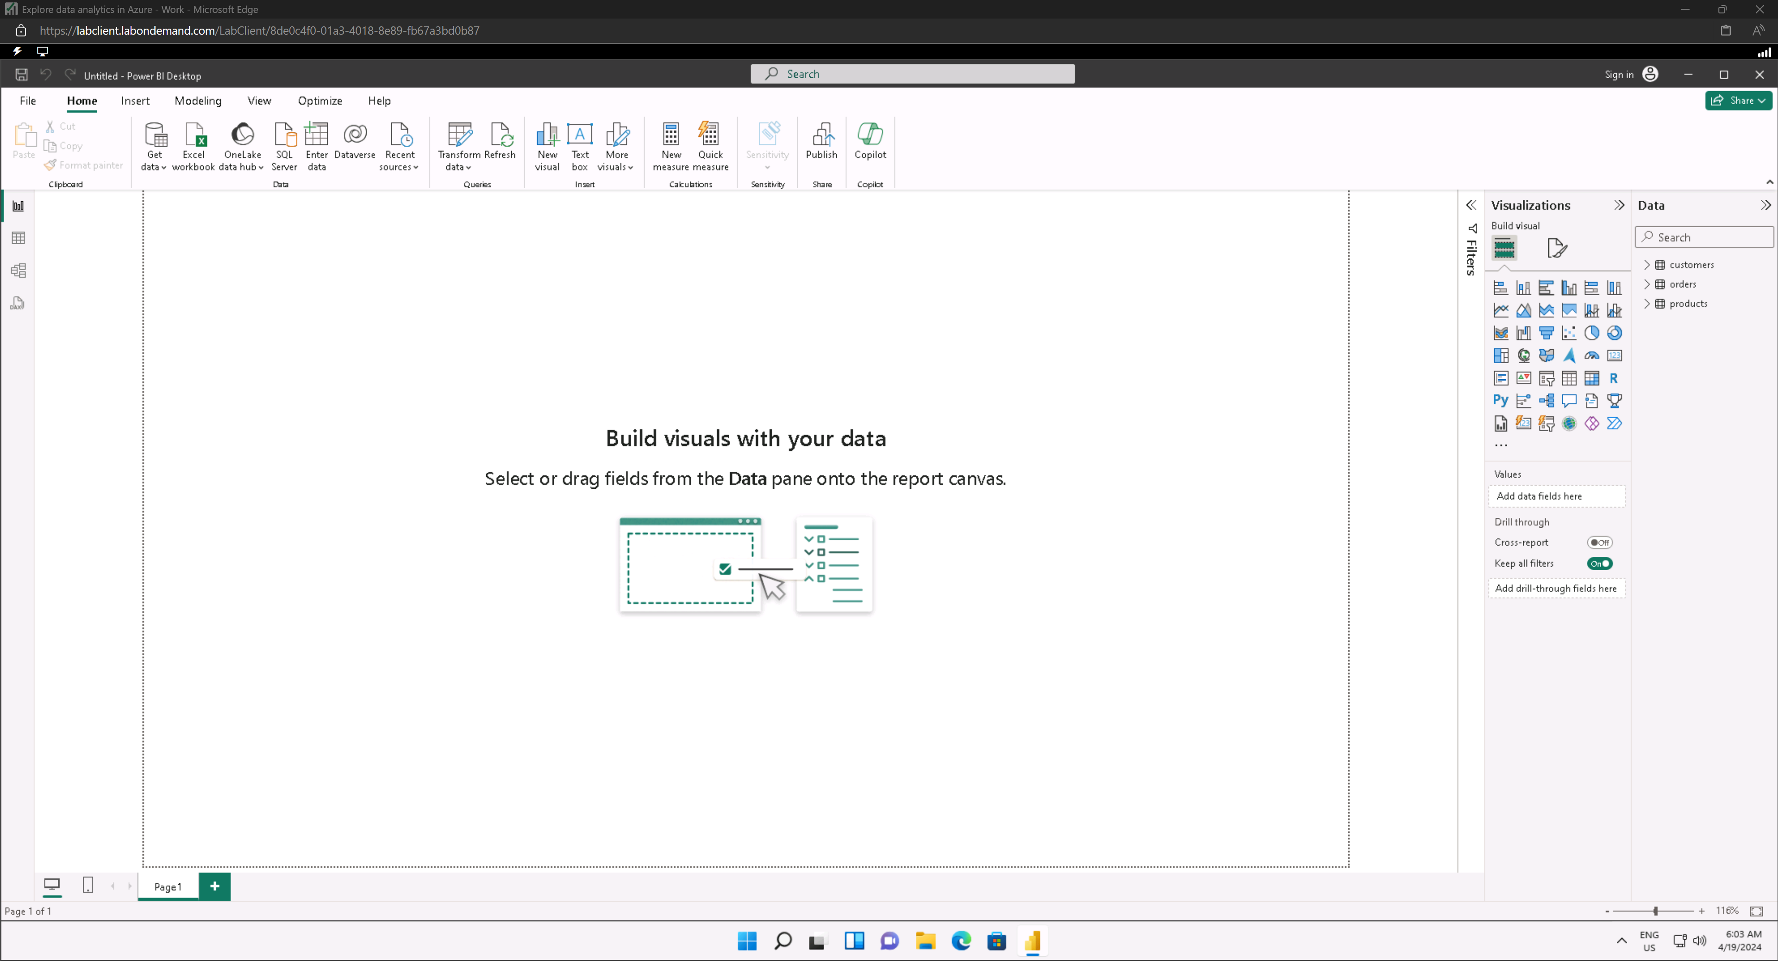

### Explore a data model

#### Model view

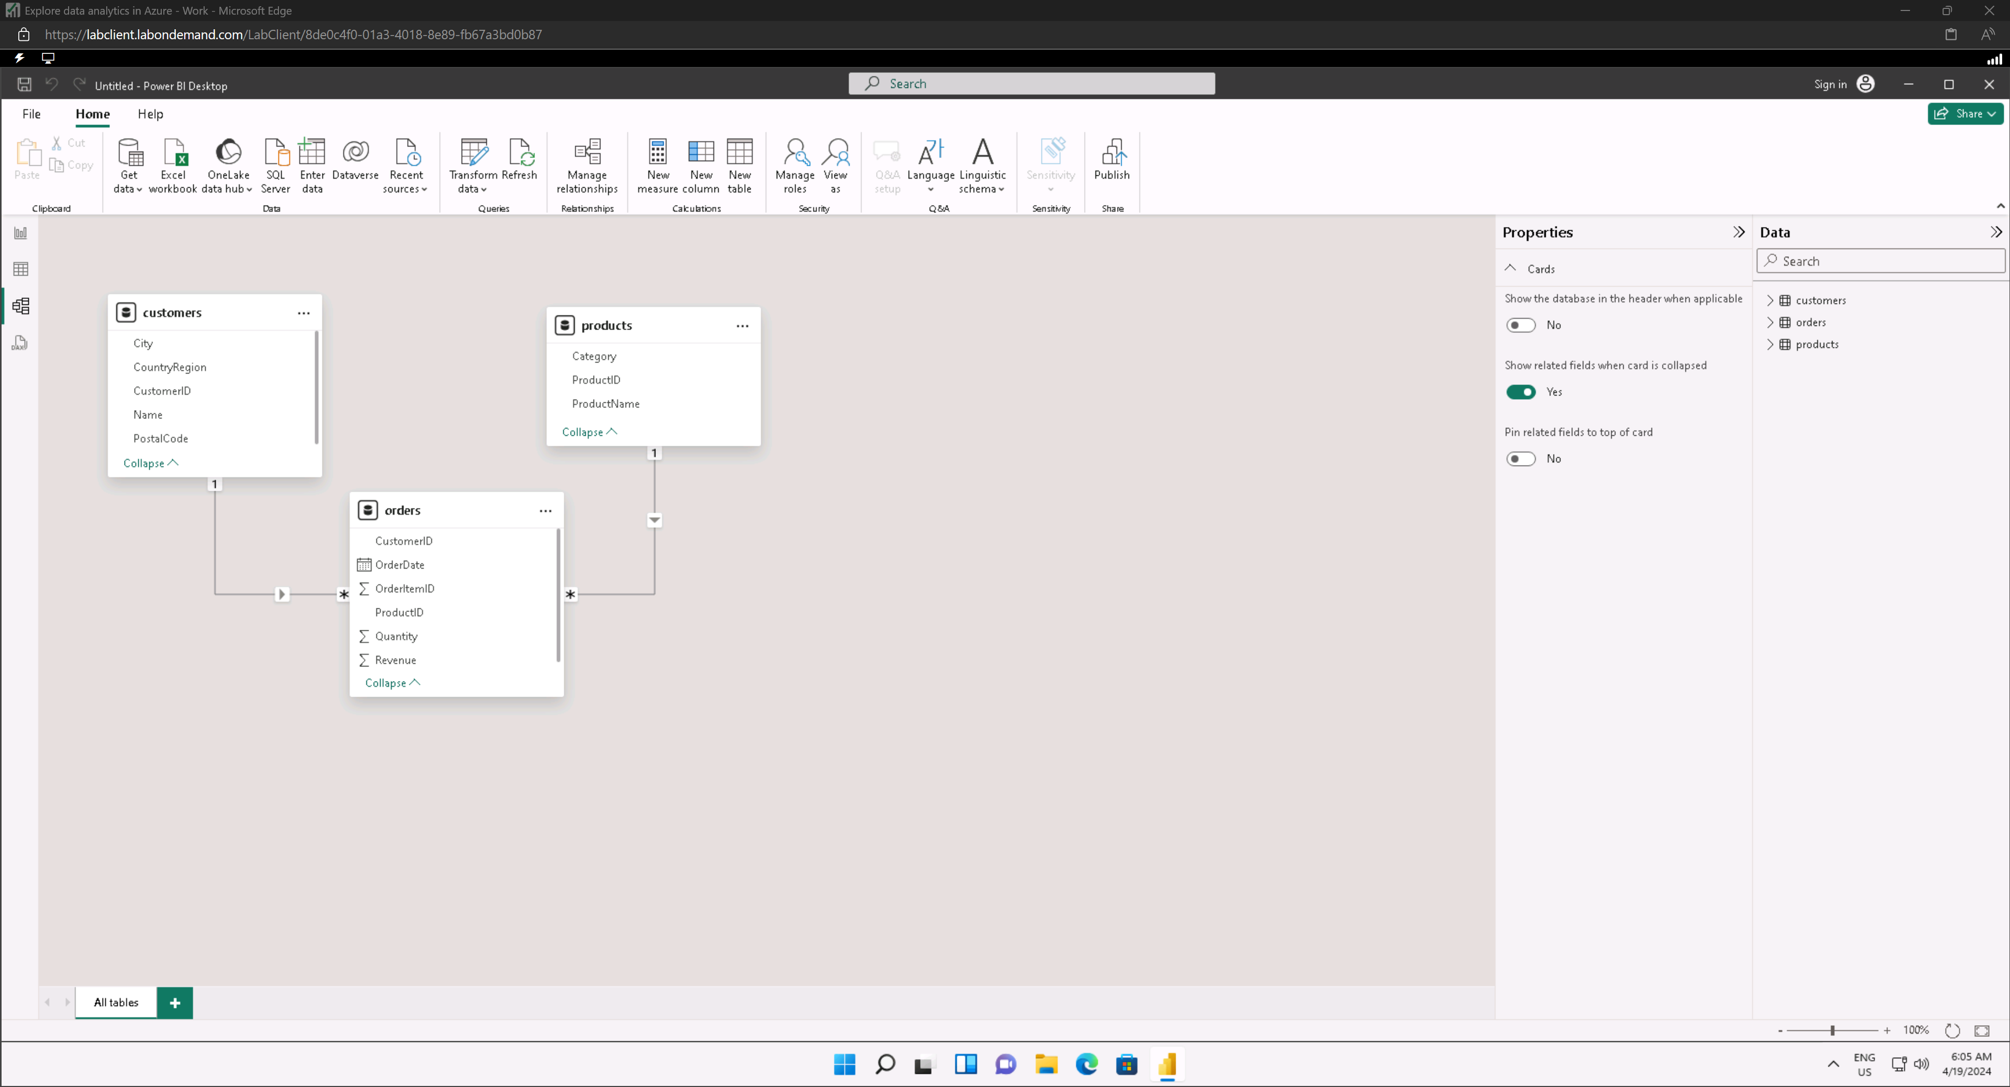

#### Set ‘Revenue’ ‘s format property to Currency

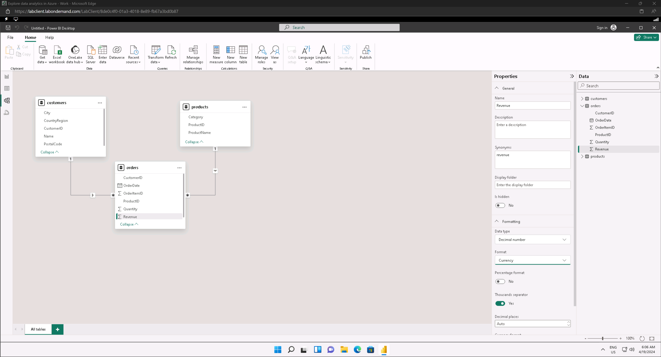

#### Create Hierarchy for ‘Category’

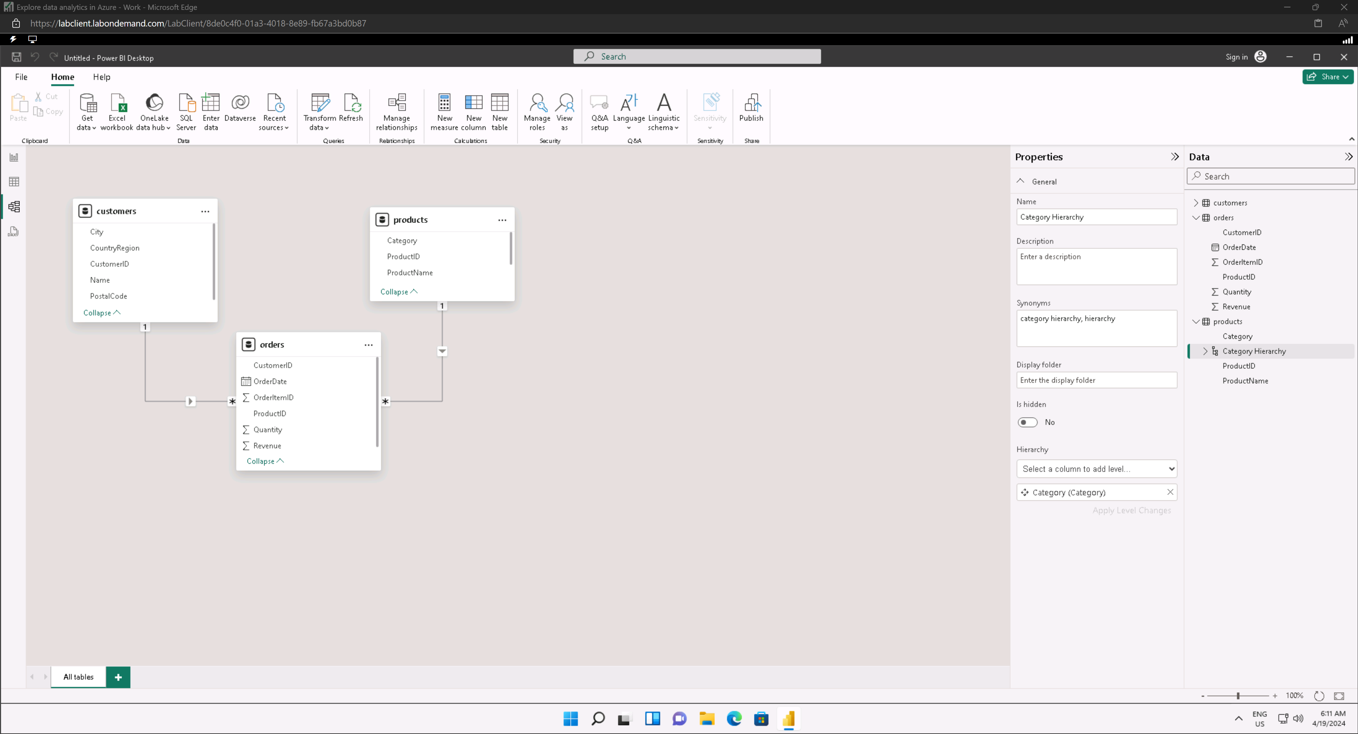

#### Add ‘ProductName’ to Category Hierarchy

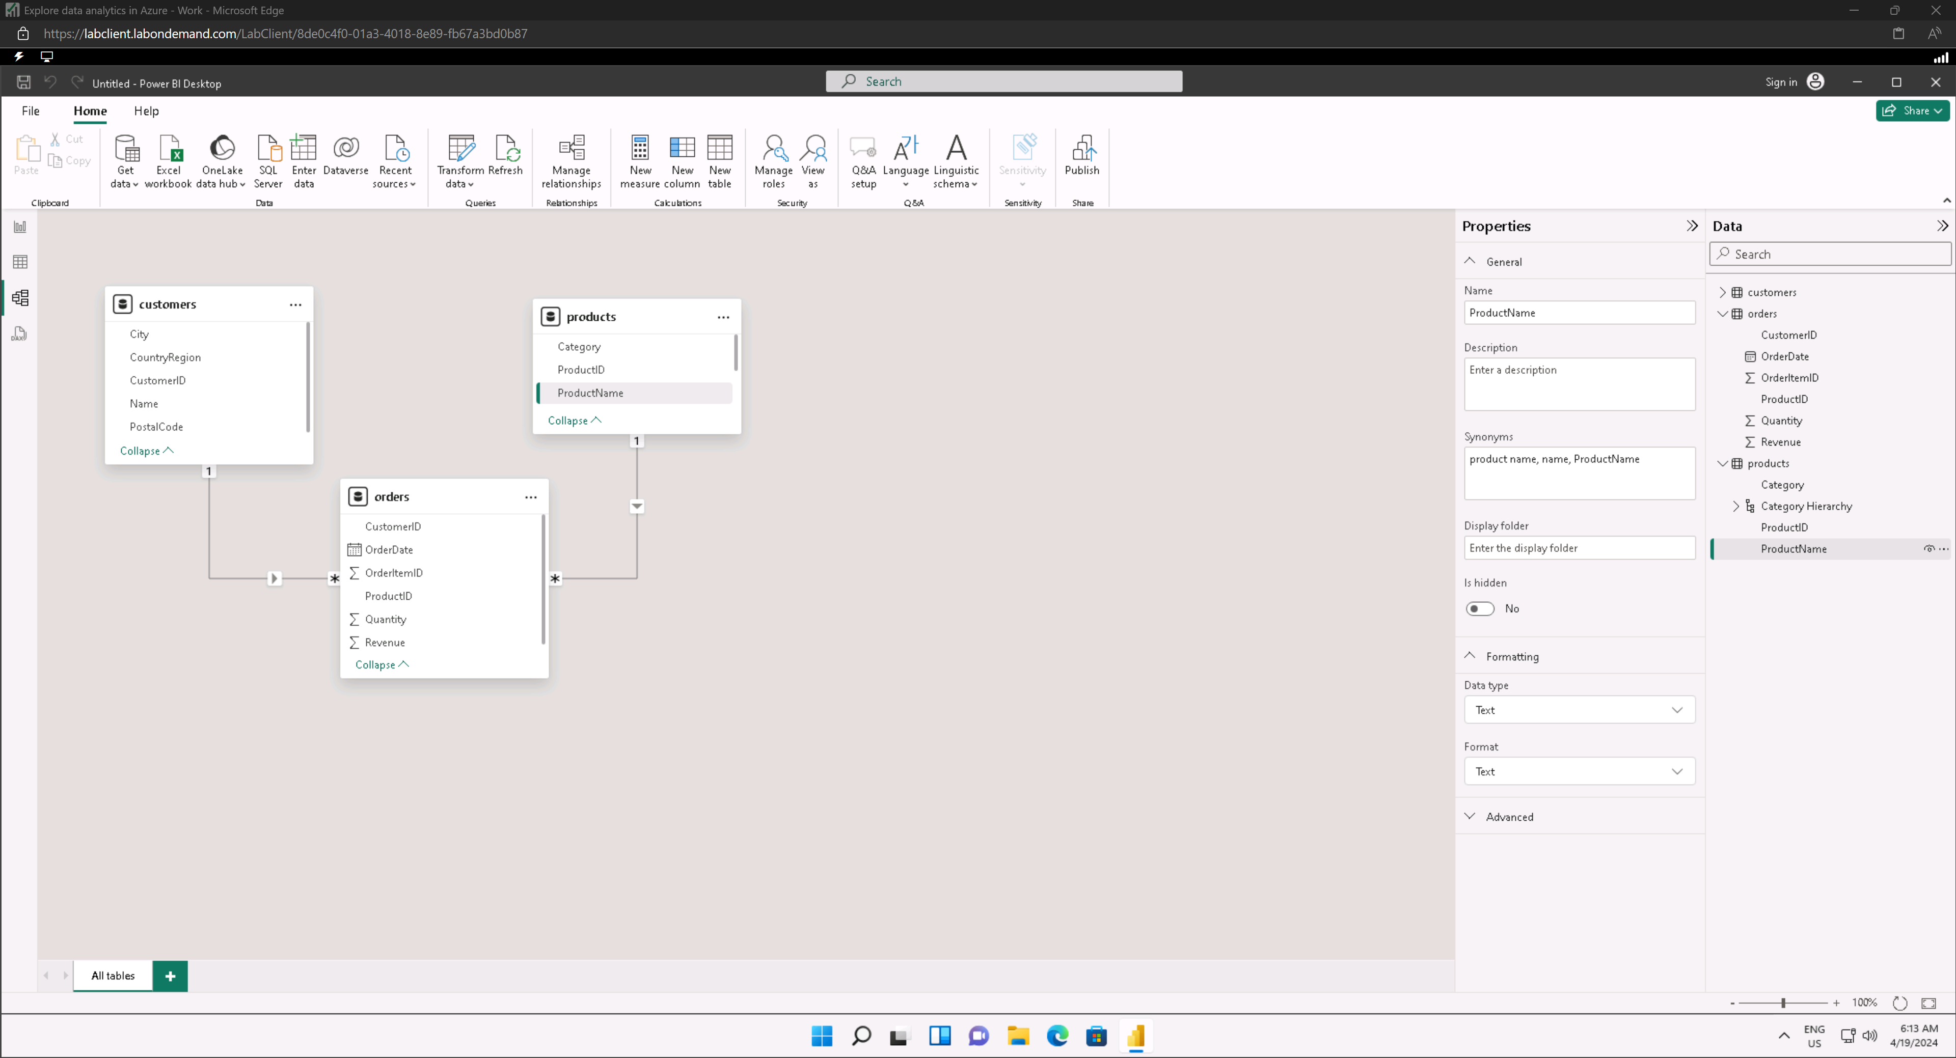

#### Set ‘City’ ‘s Data Category to City

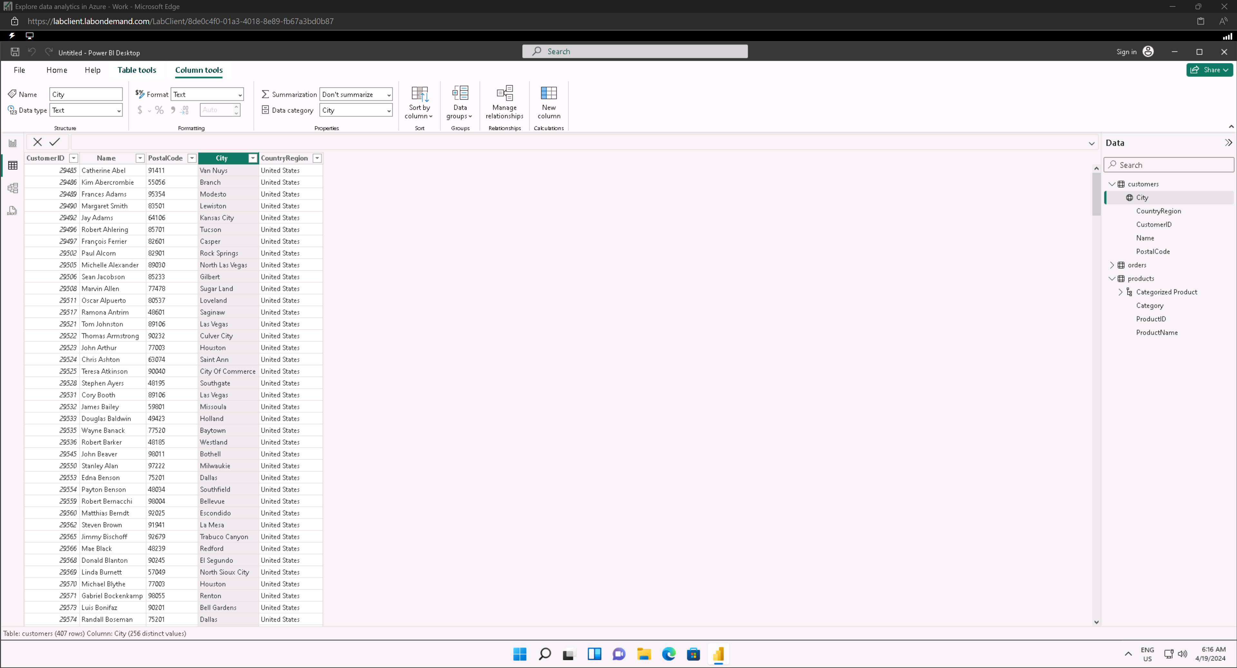

### Create a report

